Research Ireland - Defence Innovation Challenge 2026

Call SESAME Guide
July 2026

Applications not adhering to these requirements, or with incomplete content, will be deemed ineligible and will not be accepted for review, regardless of the date of submission.
It is the responsibility of the Lead Applicant to ensure that eligible proposals are received by Research Ireland on, or before, the deadline indicated. In order to safeguard against ineligibility, applicants are reminded to adhere to the guidelines in the call documentation and to review the application prior to submission in SESAME.

Contents
1 Before Starting Your Application 4
2 Eligibility Questions 6
3 Application Summary/Idea 6
4 Core/Applicant Team Details 8
4.1 Lead Applicant Details 8
4.2 Co-Applicant Details 9
5 Main Body of Proposal 10
5.1 Ethical Issues 10
5.2 Sex/Gender Dimension in Research 11
6 Budget 12
6.1 Completing the SESAME Budget Section 12
6.2 Budget Justification 15
7 Research Proposal Documents 16
7.1 Pre-Application Engagement, Team, Challenge, Solution & Societal Impact (Upload, max. 6 pages) 16
7.2 References (Upload, max. 1 page) 16
8 Letters of Support (Uploads; max. 2 pages for each letter) 16
9 Application Preview 17
10 Applicant Agreement to Terms and Conditions 18
11 Research Body Approval 19
12 Proposal Submission 19

This document (Research Ireland - Defence Innovation Challenge 2026 SESAME Guide) provides the applicants with guidelines to complete their application on Research Ireland’s Grant Management System SESAME for the Research Ireland - Defence Innovation Challenge 2026 Call. This Guide should be read in conjunction with the Call Document, and should be referenced for completing and submitting applications. Applications for the Research Ireland - Defence Innovation Challenge 2026 will only be accepted through SESAME.
Access to SESAME is granted by staff at the Research Office of your host Research Body. Please follow your internal organisational process to request this access for both Lead Applicant and Co-Applicant if either or both applicants do not have a SESAME profile already. Once you have been registered by your Research Office, you will receive an email containing your Username, Password, and Access PIN.
You will need your username and password to log in to SESAME.
SESAME is accessed using the internet; no additional software needs to be installed. You can access SESAME online from any location. The configuration of some browsers and internet infrastructure (popup blockers, firewalls, etc.) can restrict an individual’s access to the internet and as a result to the SESAME system. If you are having any such difficulties, please contact your organisation’s internal IT support team.

The SESAME system is accessed using the following Internet address:
https://grants.researchireland.ie/
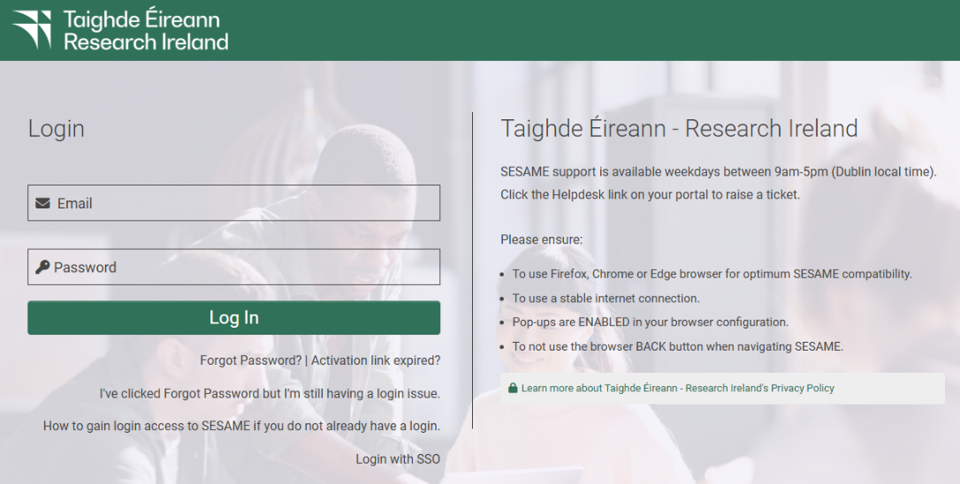

Before Starting Your Application
Before starting the application process on SESAME:
- Refer to the Research Ireland - Defence Innovation Challenge 2026 Call Document to ensure that your team is eligible to apply.
- Please ensure that both the Lead Applicant and the Co-Applicant have an ORCID ID. If you do not already have one, please go to the ORCID website and create one.
- Log into SESAME and update/create your Researcher Profile. Please note that SESAME is integrated with ORCID making it possible for you to import your publication data directly from ORCID into your Researcher Profile. For the Research Ireland - Defence Innovation Challenge 2026, the Lead and Co-Applicant are required to complete their Researcher Profile and link it to an ORCID ID before an application can be submitted.

Once you have completed these steps, navigate to your SESAME Workbench, locate the “Research Ireland Future Innovator Prize 2026 - Research Ireland-Defence Innovation Challenge” Call and click “View and Apply” button to start the application process.
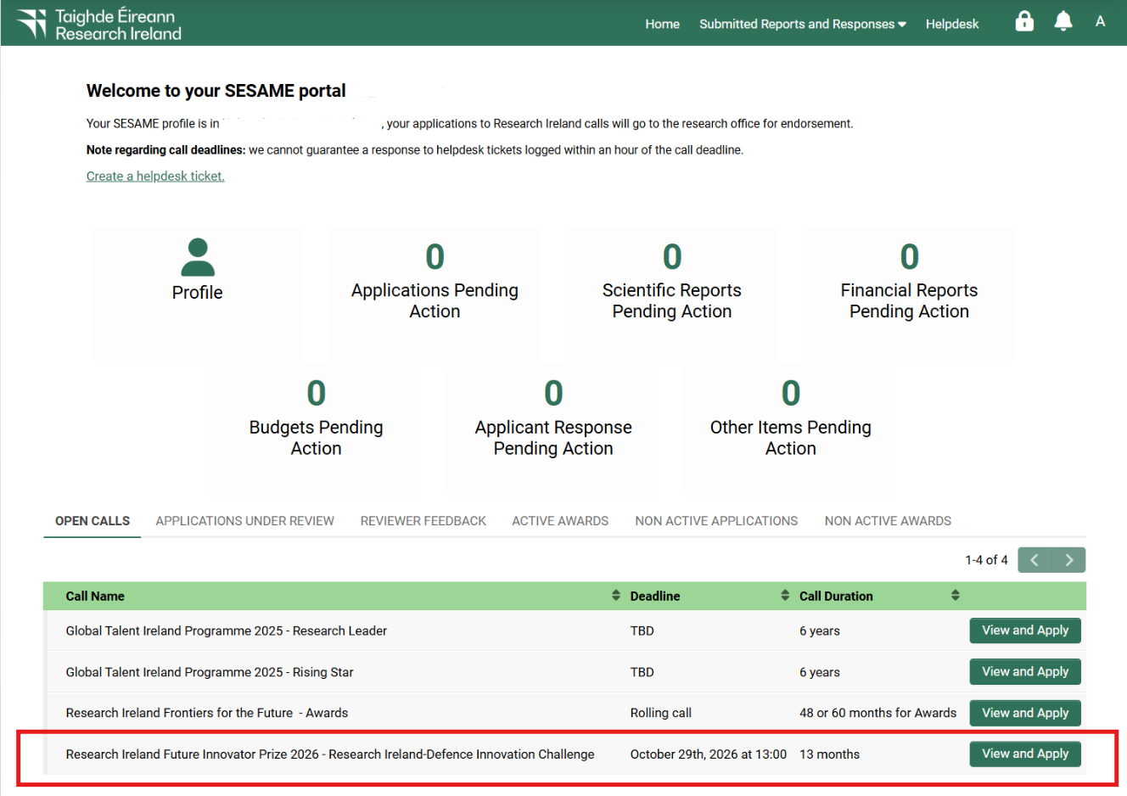
Application Process
The application is completed in a number of steps:
- Completion of field data including text boxes and drop-down boxes.
- Uploading related documents in PDF format.
- Preparing requested budget.
- Association of additional team members, as appropriate (designated during the application process as Co-Applicant / Collaborator(s)).
- Submission – once you have completed all the mandatory sections of the application, you submit it to your Research Office for review and endorsement.
You should carefully follow the instructions below to complete the various sections of the application. Please note that some sections of your application must be completed directly in SESAME, and others are completed by uploading PDF documents to SESAME.
- All text in uploaded PDFs should be provided in Aptos font, with minimum font size of 11, and at least single line spacing.
- Uploads in SESAME must be submitted in Adobe or Microsoft PDF format only.
- The number of pages in uploads must not exceed the specifications for any given section.
- Please note you must click “Save Draft” before you can upload documents, prepare budget and associate Co-Applicants. Clicking “Save Draft” after uploading documents will make these visible in the application form.
- Uploads for the Research Ireland - Defence Innovation Challenge 2026 call include Curricula Vitae for the core applicant team; Team, Challenge, Solution, & Societal Impact application document; 1-page Reference list; Budget Justification document; and Letters of Support.
- Applicants must use the templates provided on the call website.
- Appendices or other unsolicited documentation are not permitted and will be redacted from the application before review.
- File sizes of attachments should be less than 2 GB.
- Applicants and Co-applicants must complete all mandatory Researcher Profile fields (marked in red) before submitting an application. It is not possible to submit an application without completing these fields.

Eligibility Questions
Lead Applicants are required to complete the eligibility question upon commencing an application to the Challenge call (see Section 5 of the Call Document for eligibility details).
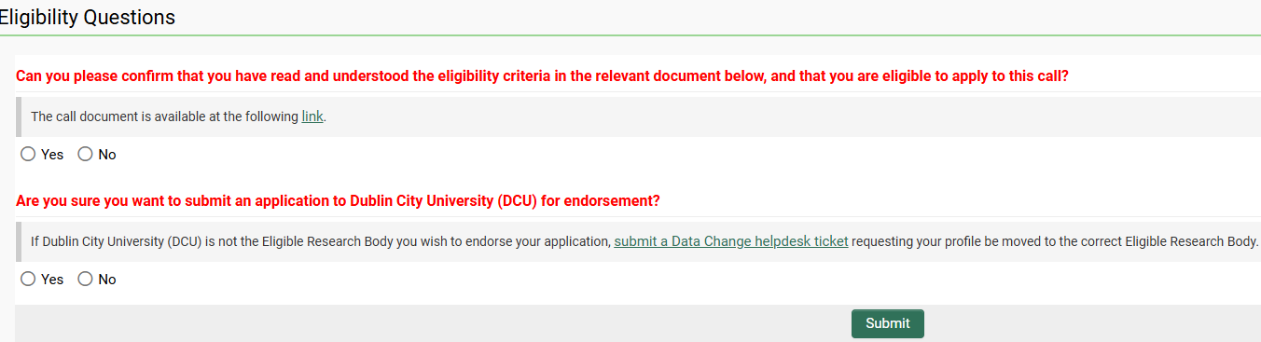
Please note that the Lead Applicant completes the eligibility question on behalf of the Core Team.

Application Summary/Idea
- Title
The title should clearly convey the challenge/problem to be addressed and should not contain confidential details, given that the titles of funded applications are published by Research Ireland.
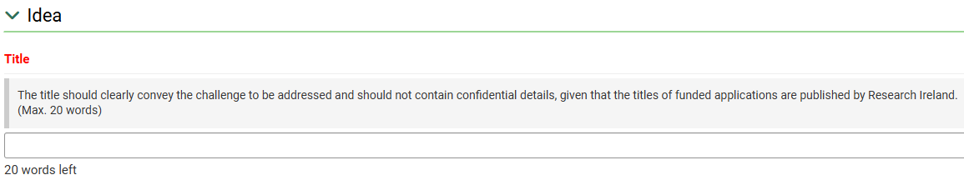
- Summary
Provide a brief, non-confidential summary of your idea clearly describing the challenge/problem and your solution. Describe what is unconventional about your approach, why you expect it to succeed and how it will deliver impact. How will the work you describe be performed within the budget and timeline?
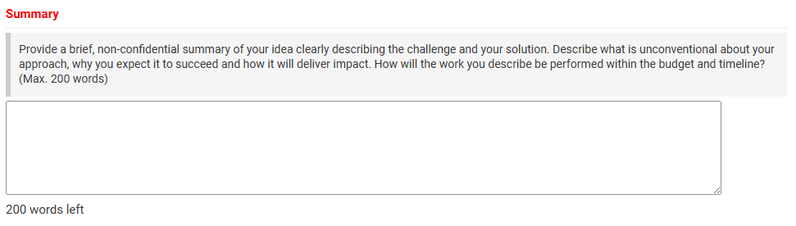

- Resubmission Statement
As part of an application to Research Ireland, a declaration must be provided as to whether a new submission relates to a previously submitted application to any Research Ireland scheme. If the application is a resubmission, a statement referencing the previous application and explaining any differences must be provided referring to reviewer comments where relevant. This statement will assist Research Ireland in the assessment of eligibility of a revised application and will not be shared with reviewers. See Research Ireland’s Resubmission policy for further details.
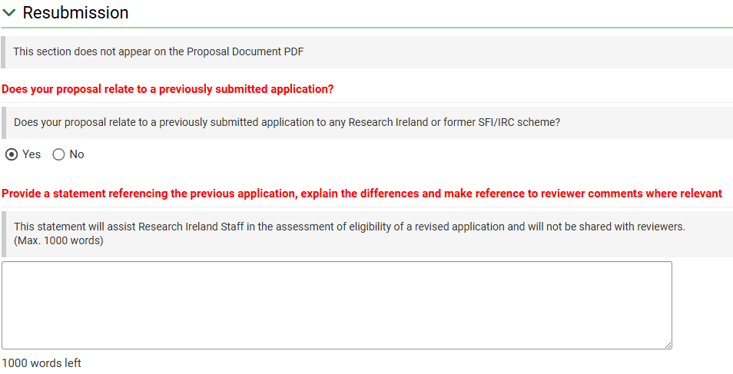
- Research Alignment
Select one of the Primary Priority Areas, from the drop-down menu, to which your application aligns, and which best describes the proposed research. It is also possible to select a Secondary Priority Area that the research will be relevant to.
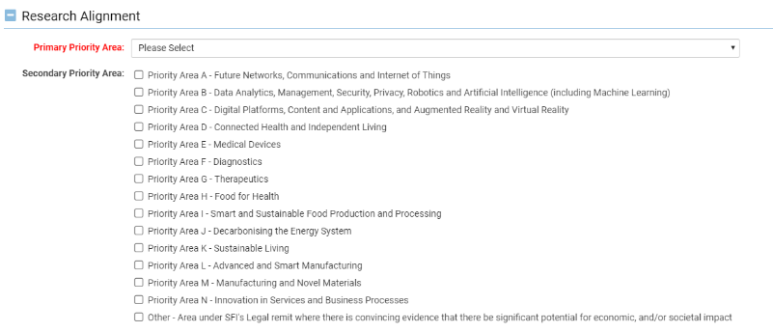
- Research Area (Primary)
Select a primary Research Ireland research area, from the drop-down menu, which best describes the proposed research.
- Research Area (Secondary)
Select a secondary Research Ireland research area, from the drop-down menu, which in combination with the primary Research Ireland research area already selected best describes the proposed research.

Core/Applicant Team Details

Lead Applicant Details
Prior to completing this section of the application form, please ensure that you have completed the mandatory SESAME researcher profile information, including Year of PhD (or equivalent degree).
- Lead Applicant CV (Upload, max. 3 pages)
A three-page CV of the Lead Applicant is required. Please use the Narrative CV template (MS-Word) provided on the Research Ireland - Defence Innovation Challenge 2026 Call webpage. After completing the template, convert it to PDF format before uploading it to SESAME.
Please click Save Draft after uploading the CV to make it visible in the application form.
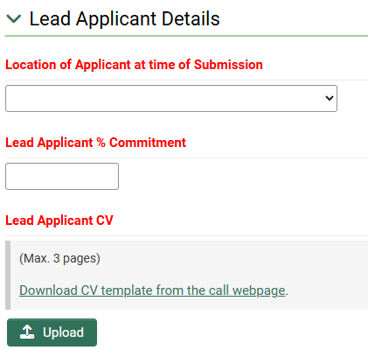
Note: % Commitment to Project - Given the objectives and timelines of the Research Ireland - Defence Innovation Challenge 2026, applicants should ensure that their time commitment is appropriate for the highly competitive nature of the programme.

- Lead Applicant supervisory experience

Please fill in all the mandatory fields marked in red under the Lead Applicant Details section.
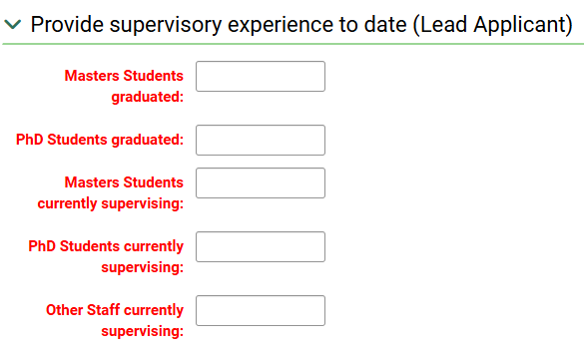

- Please note that under the Research Ireland - Defence Innovation Challenge 2026, core applicant teams must consist of two members.
- In addition to the Team Lead, all applications must include a Team Co-Lead (to be entered as a Co-Applicant).
- Both the Team Lead and Team Co-Lead must use the CV Template provided on the call website and follow the guidelines for preparing the Narrative CV. Refer to Section 6.1 of the Call Document for more information.
- Applicants are responsible for inputting the correct team configuration, and this will be checked automatically as part of the submission process.

Co-Applicant Details
To associate a Co-Applicant to a proposal, the Lead-Applicant will enter the Co-Applicant’s surname and SESAME PIN (Research Ireland) into the draft proposal. This will allow the Co-Applicant access to the draft proposal. Please note that you can only assign a Co-Applicant once you have saved a draft of your application. Until then, the buttons to assign individuals will not be visible.

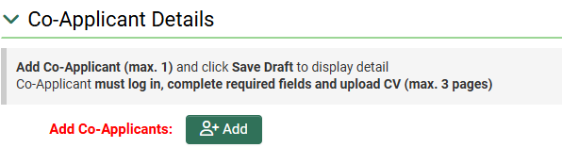

Following this, the Co-Applicant must log in and complete all the mandatory fields in their profile and in the Challenge application before the Lead Applicant can submit the application to the Research Office.
Note: SESAME does not permit two individuals to concurrently modify a proposal.
Co-Applicant and/or the Lead Applicant may choose to complete fields or upload documentation that are common to both applicants (e.g., summaries, uploads, etc.); however, only the Lead Applicant can submit an application.
Co-Applicant CV (Upload, max. 3 pages)
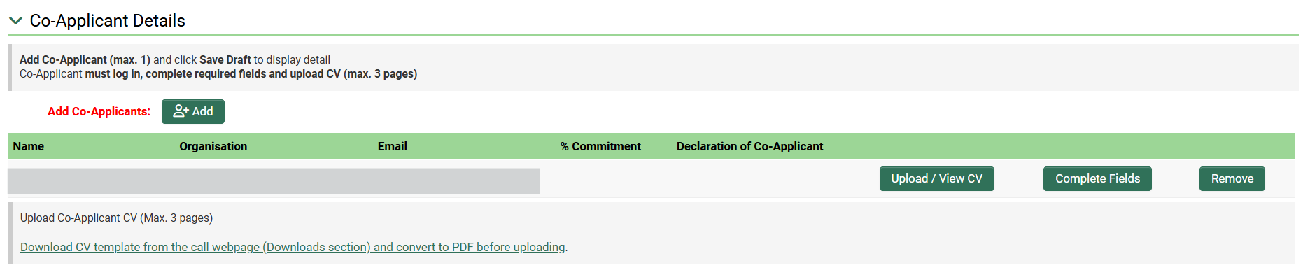
A three-page CV of the Co-Applicant is required. Please use the CV template provided on Research Ireland - Defence Innovation Challenge 2026 webpage. After filling in the template, please convert it to PDF format and upload it to SESAME. Please click Save Draft after uploading the CV to make it visible in the application form.

Main Body of Proposal

Ethical Issues
- Use of Animals
Please indicate whether animals are to be involved in any of the research planned.
- Research Involving Human Participants, Biological Material, or Identifiable Data
Applicants must indicate whether their research programme will involve human participants, human biological material or the use of identifiable (or potentially identifiable) human data. Selecting “Yes” will lead to further questions that the applicants will need to carefully consider as and if appropriate. Further details can be found on the Research Ireland Policy webpage.

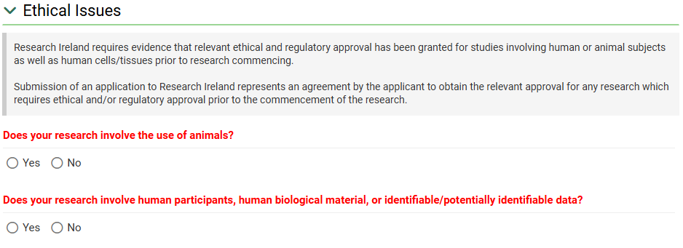

Sex/Gender Dimension in Research
In this section, articulate the considerations of biological sex and/or social gender variables in your research programmes. Please consult the Guidance for Applicants on Ethical and Scientific Issues for resources on how to address the sex and/or gender dimension of research in your proposal.
DO NOT include information on how you have or will address gender equality, diversity, and inclusion in your research team/environment; this should be addressed in the body of the proposal and/or in your CV, as appropriate.
Please consider the following questions when completing this section:
- Is sex as a biological variable taken into account in the research design, methods, analysis and interpretation, and/or dissemination of findings?
- Is gender as a socio-cultural factor taken into account in the research design, methods, analysis and interpretation, and/or dissemination of findings?
You will be prompted to provide further details to explain your response after selecting “Yes” or “No”.
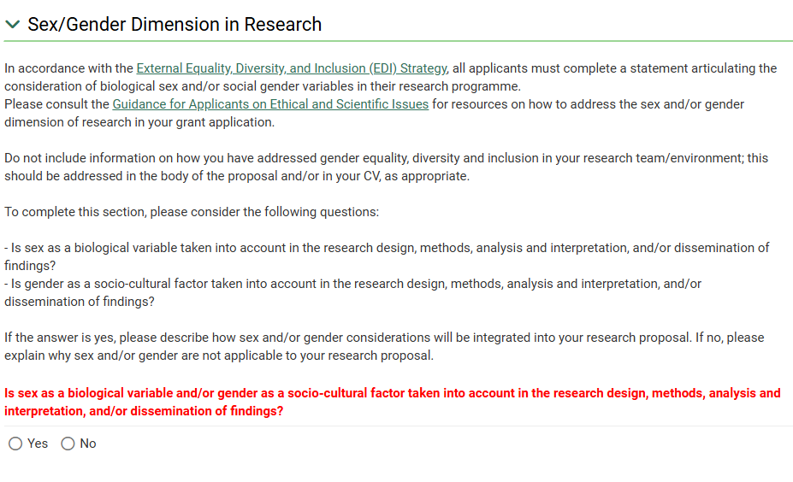

Budget
The Budget section should be used to provide a summary of the budget (direct costs) and resources you will need to complete the planned work. Given the phased nature of the Defence Innovation Challenge programme, it will not be possible to provide significant details in relation to requirements for the Seed Phase. As such, the requested budget and resources for the Seed phase should be indicative and be based on what you currently envisage. Please consult the Research Ireland Grant Budget Policy (GBP) and the Research Ireland - Defence Innovation Challenge 2026 Call Document for more information.

Completing the SESAME Budget Section
To complete the Budget section, you must fill in the Budget Details table and the Total Requested Budget table (Prepare Budget) and upload the Budget Justification document (pdf, max 2 pages).
Please note that you are required to complete two budget tables, as described below. It is recommended that you first complete the Budget Details and, when finalised, enter the totals for each category (Staff, Equipment, etc) into the Budget Table. Please note that although this is a 13-month award, at this stage, it is sufficient to enter the totals into Year 1 (the budget profile will be corrected at the point of award). The totals for each category and the overall requested budget must match in the two budget tables in order for you to submit your application.

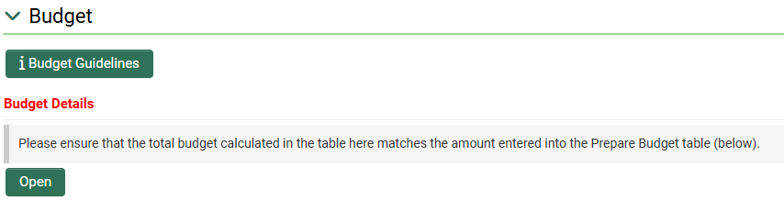

- Guidelines for Completion of Budget Details:
- Under Budget Details, click on "Open".
- To add line items to both CONCEPT and SEED sections, click on the "+" symbol under each category.
- To remove line items, click on "x" symbol to the right of each line item.
- Click "Save" and "Close".
- Prior to submission, a budget may be edited any number of times.
- Please see the Research Ireland - Defence Innovation Challenge 2026 Call Document for guidelines on how to complete your budget.
Below you can find screenshots of the Budget Details summary table, as well as detailed breakdown tables for Concept and Seed Phase requests.

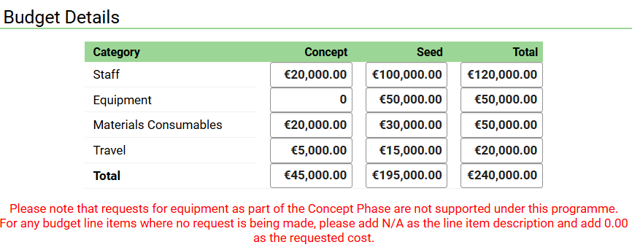

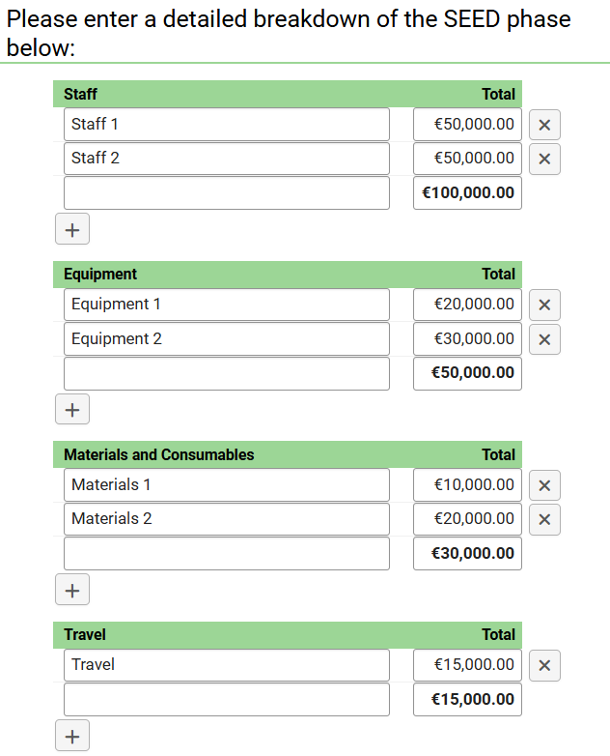
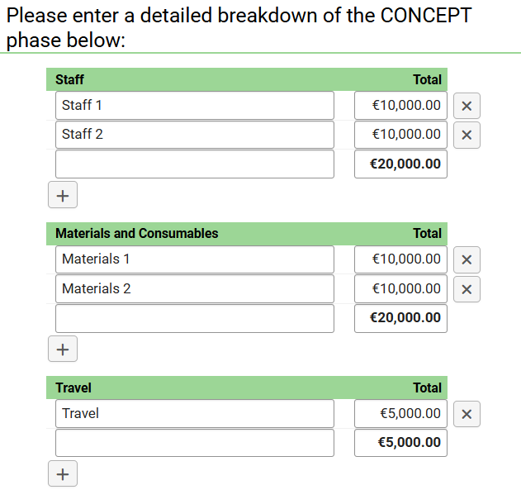

After completing the Budget Details Table, you are asked to fill in the total requested amount for Concept and Seed Phase. Click “Open” next to the Prepare Budget header and click to create a new budget within a popup window. Select the requested draft budget and click "Open Budget" to edit the budget worksheet.
- Guidelines for completion of Budget Table ("Prepare Budget"):
- Go to Prepare Budget section and click "Open".

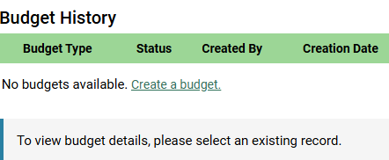
- In the pop-up window click Create a Budget.

- Select the Requested Draft budget and click "Open Budget" to edit the budget worksheet.
- For each category (Staff, Equipment, etc), please enter the total requested budget in Year 1. This must correspond to the total amount for this category in the Budget Details Table.
- To add the total, click on the "+" symbol under the budget table.
- To remove line items, click the "‐" symbol to the right of each line item.
- Click "Save" and "Close".
- Prior to submission, the budget may be edited any number of times.
- Ensure the category totals are the same on both budget tables.
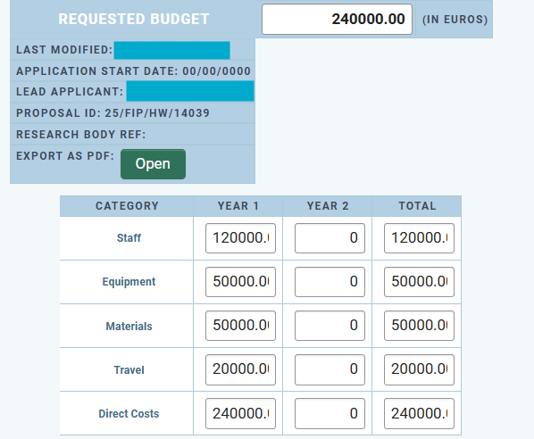 | 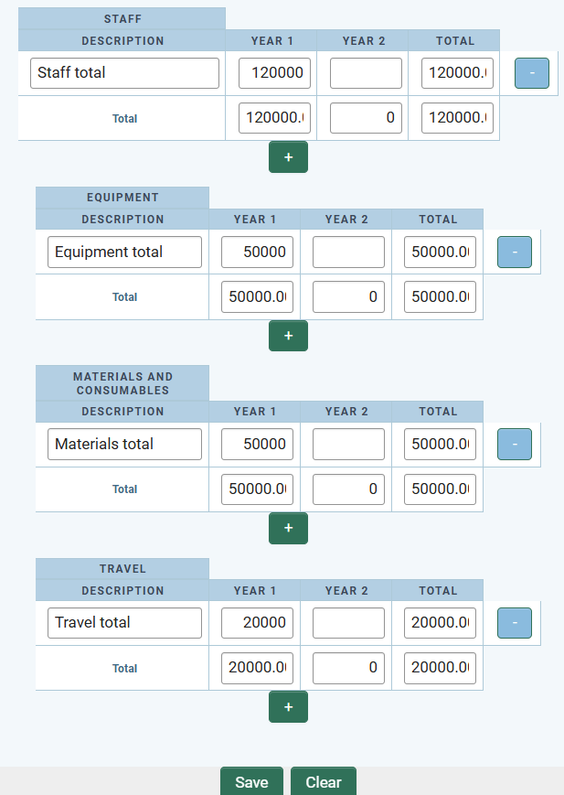

Budget Justification
After completing the budget tables, please upload the Budget Justification PDF document (max 2 pages).
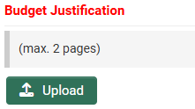

Research Proposal Documents

Pre-Application Engagement, Team, Challenge, Solution & Societal Impact (Upload, max. 6 pages)
In this section, describe the team, the challenge and solution. Please use the template provided on the Research Ireland - Defence Innovation Challenge 2026 Call webpage and refer to the Call Document for details on expected content. Note that the section describing the Team composition must not exceed one page in length. Once completed, please convert it to PDF format before uploading it to SESAME.
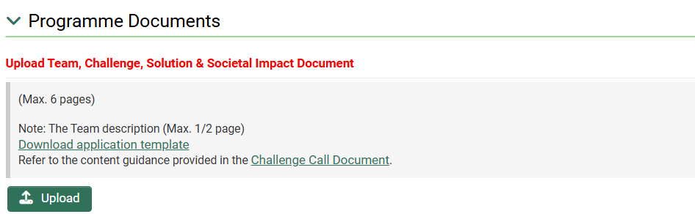

References (Upload, max. 1 page)
Appropriate references and citations for the proposed research may be provided in a separate one-page PDF document. Please use the template provided on the Research Ireland - Defence Innovation Challenge 2026 webpage.
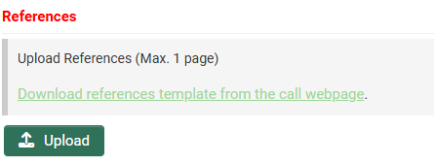

Letters of Support (Uploads; max. 2 pages for each letter)
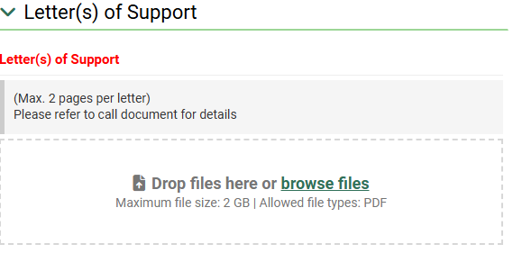

The following letters of support must be included:
- A Letter of Support from the Host Research Body of the Team Lead and the Team Co-Lead.
- Where any applicant is a postdoctoral researcher, a Letter of Support from the proposed Mentor must be provided. Please ensure the Mentor’s CV is also included in the application.
For further requirements on Letters of support please refer to Section 6.1h of the Call Document.
NOTE: No additional Letters of Support may be included at the application stage. Any additional/unsolicited Letters of Support will be removed from an application.

Application Preview
You should view the PDF of your application prior to submission to verify content of your application. Make sure to click “Save Draft” before opening PDF document to ensure all changes are updated. It is the responsibility of the Lead Applicant to ensure that all documentation is included and that the maximum page lengths are not exceeded.
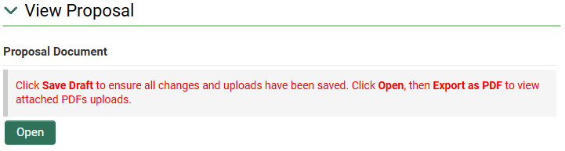
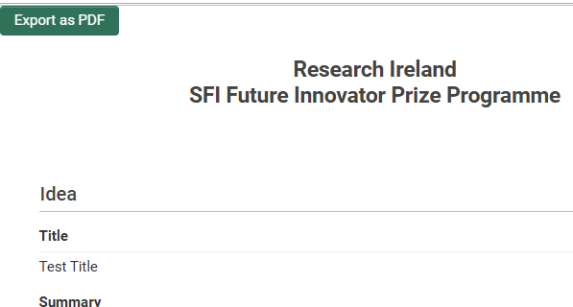

To check that required fields have been completed prior to submission, click "Validate". Validation will also automatically occur when "Submit to RO" is selected. However, it is important to note that there is no system validation on multiple upload file fields, including for example Letters of Support. The number of documents required may vary depending on each application.


Applicant Agreement to Terms and Conditions
Submission of an application confirms acceptance of and agreement with the Research Ireland Terms and Conditions of Research Grants; that the applicant meets eligibility requirements; that the project is in full agreement with all legal and regulatory matters governing research in Ireland; that no aspect of this project is already being funded from another source; and that all details provided are correct.
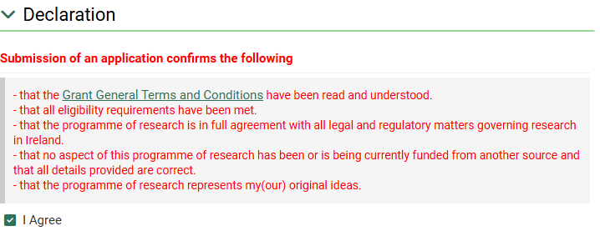
Please note a new field, mandatory for completion for all applications to Research Ireland. You are asked to declare if any generative AI was used in the preparation of the application, and if it was utilised, a description of the tools, their versions and the extent to which they were applied must be described. In this case, you are also asked to confirm that the application was reviewed for any inaccuracies, hallucinations, bias, or potential plagiarism.
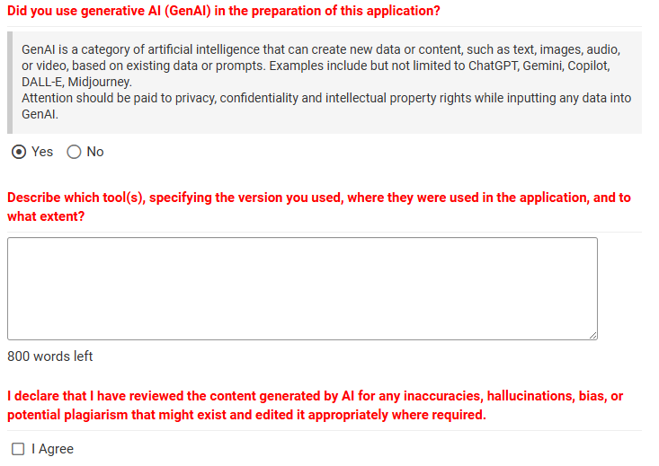

Research Body Approval
For an application to be accepted, it must be authorised for submission by the host research body of the lead applicant. It should be noted that Research Body submission of an application confirms that the Research Ireland Grant General Terms & Conditions have been read and understood. Submissions may only be made by an authorised representative of the Research Body of the Lead Applicant.
As Applicant, please ensure that sufficient time for the Research Office review and authorisation is provided and follow internal guidance/timelines.

Proposal Submission
Once you have filled in the application fully, previewed the PDF, and agreed with the Research Ireland terms and conditions, click on “Submit to RO”. A submission is made initially to the Research Office of the Lead Applicant for approval, prior to final submission by the Research Office to Research Ireland. The Full Proposal Application Deadline below is for the Research Body to submit endorsed application.
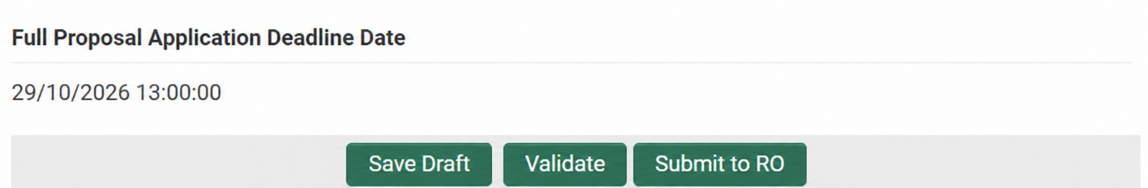

Once submitted by the host Research Body to Research Ireland through SESAME, an application cannot be withdrawn and subsequently modified for resubmission in the same call, regardless of the date of submission.
Please contact the Research Office well in advance in order to obtain registration details for SESAME and to become familiar with any internal Research Body submission deadlines.
Applications must be received by Research Ireland no later than
Deadline: 13:00 (Dublin Local Time) on 29 October 2026.
Please note that after the submission deadline, applications can no longer be submitted in SESAME.
Submitted applications that do not include all required documents will be made ineligible.
If you are unsure of the document requirements, please contact challenges@researchireland.ie
Applicants will receive a notification from SESAME periodically when the status of their proposal changes. Alternatively, the status of a proposal (e.g., where a proposal is pending Research Office approval or is under review at Research Ireland) is displayed in SESAME.

Call Document
http://orcid.org/
Call Document
Resubmission Policy
Call Webpage
Policies - Research Ireland
Guidance on Ethical and Scientific Issues
https://www.researchireland.ie/about/policies/
Application Form
References Template

