Research Ireland Who Can Apply Policy

Taighde Éireann | Research Ireland (Research Ireland) is committed to supporting individuals throughout their academic career lifecycle (or career progression). Research Ireland recognises that supporting such individuals is the foundation to building research capacity, expertise, and reputation through funding excellent research. To this end, Research Ireland has developed a suite of programmes that provide researchers with an opportunity to advance their programmes of research and mentoring experience whether they are contracted to a single entity (as defined in this policy) or hold a secondary appointment.

Please note, the Research & Innovation Act 2024 upon which Research Ireland is established, defines the ‘entity’ or Eligible Research Body as the applicant, and the ‘individual’ as applying for funding or submitting an application for funding, on behalf of the applicant.

The policy: To be eligible to submit an application for funding under a Research Ireland Programme Call, on behalf of an applicant an individual must satisfy one of the following two categories:
- An individual who holds a primary contract of employment, that is, an employment contract in which the researcher devotes a minimum of 50% of a full time equivalent (FTE) with an Eligible Research Body (ERB). This might include:
- Permanent members of the academic or non-academic staff at an ERB who hold a primary contract of employment that will span the duration of the Grant awarded.
- Academic or non-academic members of staff/employees of an ERB who hold, or will hold, a primary contract of employment that will span, at least, the period of the Grant and who will be recognised by the ERB as an Independent Researcher from the time the Grant commences and for at least the duration of the Grant (if awarded).
- As may be permitted by a Programme Call, a person who is a registered student (or who intends to register as a student) of an applicant
- An Emeritus/ ‘retired’ Professor provided that the host ERB provides a letter signed by the Vice-President of Research (or equivalent) which confirms that there is commitment from the Research Body as set out in the Research Ireland Policy for Emeritus/ ‘retired’ Professor.

- A Clinical Researcher/Scientist who is either employed by, or affiliated with, an ERB and who holds a minimum 50% employment contract with a clinical research facility/practice within the public health system in Ireland.

Applicants with industry affiliations
Individuals who hold a contract of employment (whole or in-part, primary or secondary) with industry or any other private sector entity, are not deemed eligible to apply. In such instances, these individuals should contact the relevant Research Ireland Programme Manager for further information.

Applicants who hold secondary appointments
Research Ireland recognises a secondary appointment as concurrent, defined by a contract of employment, working arrangement or conferment of title or privileges, with another ERB, or a Research Performing Organisation that is not an existing approved ERB, or a public body, and which may or may not be based in Ireland. Where an applicant holds such an appointment, the following will apply:

Secondary appointment categories: Research Ireland recognises and supports four main categories of secondary appointments and affiliations, namely Titular Academic, Healthcare, Administrative and Interorganisational-Joint, as well as several subcategories thereunder (Figure 1). Full definitions can be found in Research Ireland’s Secondary Appointments Framework Related Terms and References: https://media.researchireland.ie/wp-content/uploads/2026/07/Research-Ireland-Secondary-Appointments-Framework-2026.docx

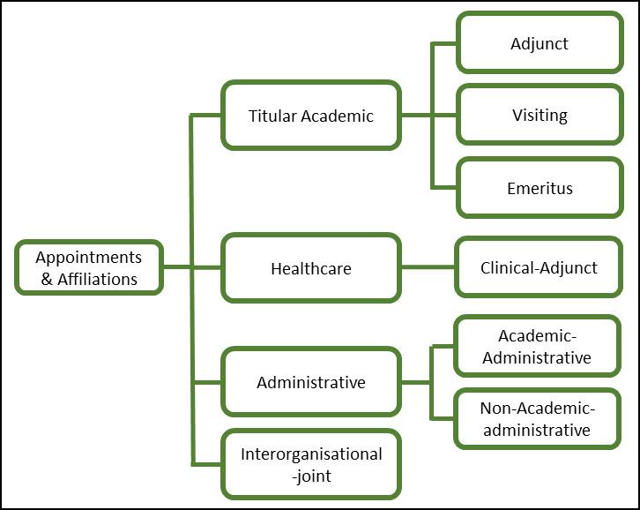
Figure 1. Research Ireland Framework of secondary appointments and affiliations.

What to do: Applicants who hold a secondary appointment at the time of submitting an application to Research Ireland for Grant funding, or who intend to hold a secondary appointment during the term of the Grant, if awarded, must notify Research Ireland at the submission stage of their Grant application with the details of the appointment. Where a Grant holder’s status changes during the term of the Grant, they must contact the relevant Research Ireland programme call email inbox (as per the Research Ireland Grant General Terms & Conditions and outline how their ability to maintain their time commitment to the Grant, complies with that specified in their approved application for funding or as specified in the Letter of Offer .

Considerations for the Letter of Support: The host ERB should be informed about the applicant’s secondary appointment and, in the Letter of Support, confirm their capacity to allocate a sufficient percentage of their time to the Research Programme as outlined in the Programme call guidance. Furthermore, where applicable, the host ERB should confirm its recognition of the applicant as an Independent Researcher.

Research and Innovation Act 2024
Eligible Research Bodies | Research Ireland
This policy does not apply to individuals intending to apply for funding under the Research Ireland Discover Programme.
Art 36.3 of Research and Innovation Act 2024: An application may be submitted to the Agency on behalf of an applicant by an employee of the applicant or, as may be appropriate, a person who is a registered student (or who intends to register as a student) of the applicant.
For a complete list of Eligible Research Bodies, please see Research Ireland’s Eligibility Information.
An Independent Researcher, sometimes referred to as an “Independent Investigator” or “Established Researcher”, is an individual who conducts research independently, identifies research problems and opportunities, selects appropriate methodologies and approaches, advances a research agenda, and has the ability to establish collaborative relationships. They are able to attract funding, lead a research group, and demonstrate autonomy in conducting their research. They will be recognised and supported as an Independent Researcher by an Eligible Research Body (adapted from the European Commission’s definition for “Established Researchers”)
With the exception of the Research Ireland Discover Programme, individuals who hold a contract of employment with industry or any other private sector entity may be eligible to apply if said employer is applying with an ERB within the context of a programme operating under a State aid exemption (GBER).
In which the researcher devotes no more than 50% of their time commitment.
Including both formal and informal agreements and/or contracts where the terms and conditions are clearly defined and understood by all parties.
Subject to an individual Programme Call’s eligibility requirements being met.
With reference to the Research Ireland Framework of Secondary Appointments.
Relating to their secondary appointment.
As per the Programme call guidance.

