

2026 GOVERNMENT OF IRELAND POSTDOCTORAL
FELLOWSHIP SCHEME

RESEARCH OFFICE GUIDE TO THE ONLINE SYSTEM

Key Dates
Call Open: 12:00 (Irish time) 11 September 2025
FAQ deadline: 16:00 (Irish time) 16 October 2025
Applicant deadline: 16:00 (Irish time) 23 October 2025
Mentor deadline: 16:00 (Irish time) 06 November 2025
Research Office Endorsement deadline: 16:00 (Irish time) 13 November 2025
Call outcome: End of April 2026
Grant start date: 01 September 2026

Due to heavy server traffic on the day of the applicant and mentor deadlines, all participants are strongly advised to submit their forms well in advance of the relevant deadline.

Logging into the online system:

- The grants management system is only compatible with the two most recent versions of Firefox, Chrome, Internet Explorer and Safari.
- Research officers who are registered on Research Ireland’s online system should have received a confirmation email containing their username (email address) and password.
- If you have lost or forgotten your password, navigate to the link above and click ‘forgot password?’. A system-generated password will be forwarded to your email address. If you do not receive this email, please check your spam folder. Please note that it may take up to 15 minutes to receive the email containing your new password.
- If you do not receive this email, please check your spam folder and ensure that the noreply@researchireland.ie email address is on your ‘safe senders’ list. You may need to check with your IT department to ensure there is no issue with your organisation’s internal firewall.
- If you have a technical issue registering for the online system, please email system@researchreland.ie for further assistance.
- Once logged in, a home screen will be displayed with the following icons:
      - Open Calls
      - Applications Pending Endorsement
      - Draft Applications
      - Submitted Applications
      - Outcome Applications

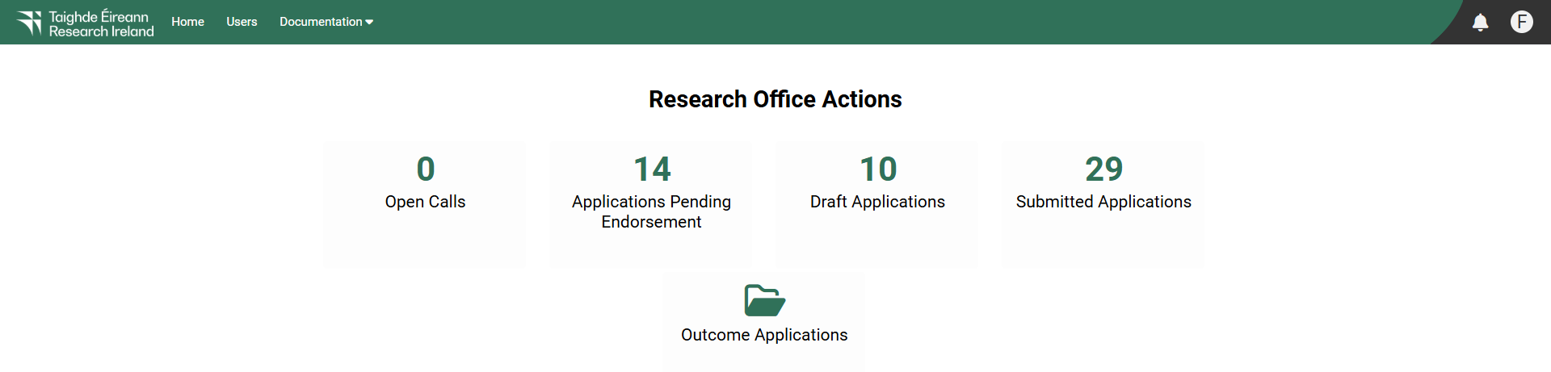

Please note that you can sort the applications by their programme by clicking on “Application Type” (eg. PostDOCTORAL (Government of Ireland))

Viewing applications in draft status:

- Click on the ‘draft applications’ icon to view any draft applications associated with your eligible research body.

- Please note that you can sort the applications by their programmes by clicking on “Application Type” (e.g. Postdoctoral (Government of Ireland)).

- The following information will be visible for applications in draft status:

- Project ID
- Applicant’s name and email address

Project title
- Type of Application (ie. Postdoctoral fellowship – Government of Ireland)
- A PDF of the draft application (Print (PDF)’ button)

- All applications require a mentor to be added as a participant. It is not possible to add a secondary mentor to a postdoctoral application although it is possible to acknowledge advisors/mentors in the “Training and Career Development Plan” section for training in relation to specific tasks and career development.
- Mentors may support no more than one applicant to the Government of Ireland Postdoctoral Fellowship programme. As such, Mentors should endorse only one submitted application. If the Research Office endorses multiple applications with the same Mentor, all applications will be deemed ineligible.
- The mentor can only complete their form once the application has been submitted.

Submitting a research office endorsement decision:

- By endorsing an application on behalf of your eligible research body, you are confirming that the organisation supports the application. You are also confirming the eligibility of the applicant, and the eligibility and suitability of the proposed mentor to support the applicant.
- Mentors may support no more than one applicant to the Government of Ireland Postdoctoral Fellowship programme. As such, Mentors should endorse only one submitted application. If the Research Office endorses multiple applications with the same Mentor, all applications will be deemed ineligible.
- Institutional endorsement should be declined where significant shortcomings are identified in an application including, but not limited to, non-compliance with institutional research ethics policies and/or the Terms and Conditions for the programme.
- Applications that are not endorsed by the eligible research body by the deadline indicated in the Call document will automatically be deemed ineligible.
- In order to view the list of submitted applications awaiting endorsement from your eligible research body, click on the ‘applications pending endorsement’ icon on the home page.
- Applications without the required participant forms (mentor forms) completed in full and submitted via the online system will automatically be deemed ineligible and will not be considered for funding. Please also see section 6 of the Call Document for additional information on applications that will be deemed ineligible and will not be considered for funding.
- Click on the Applications Pending Endorsement icon on the home screen to open it. Once this has opened, a new screen listing all the applications awaiting endorsement will appear.
- Click the ‘open’ button beside the relevant application in order to view it:

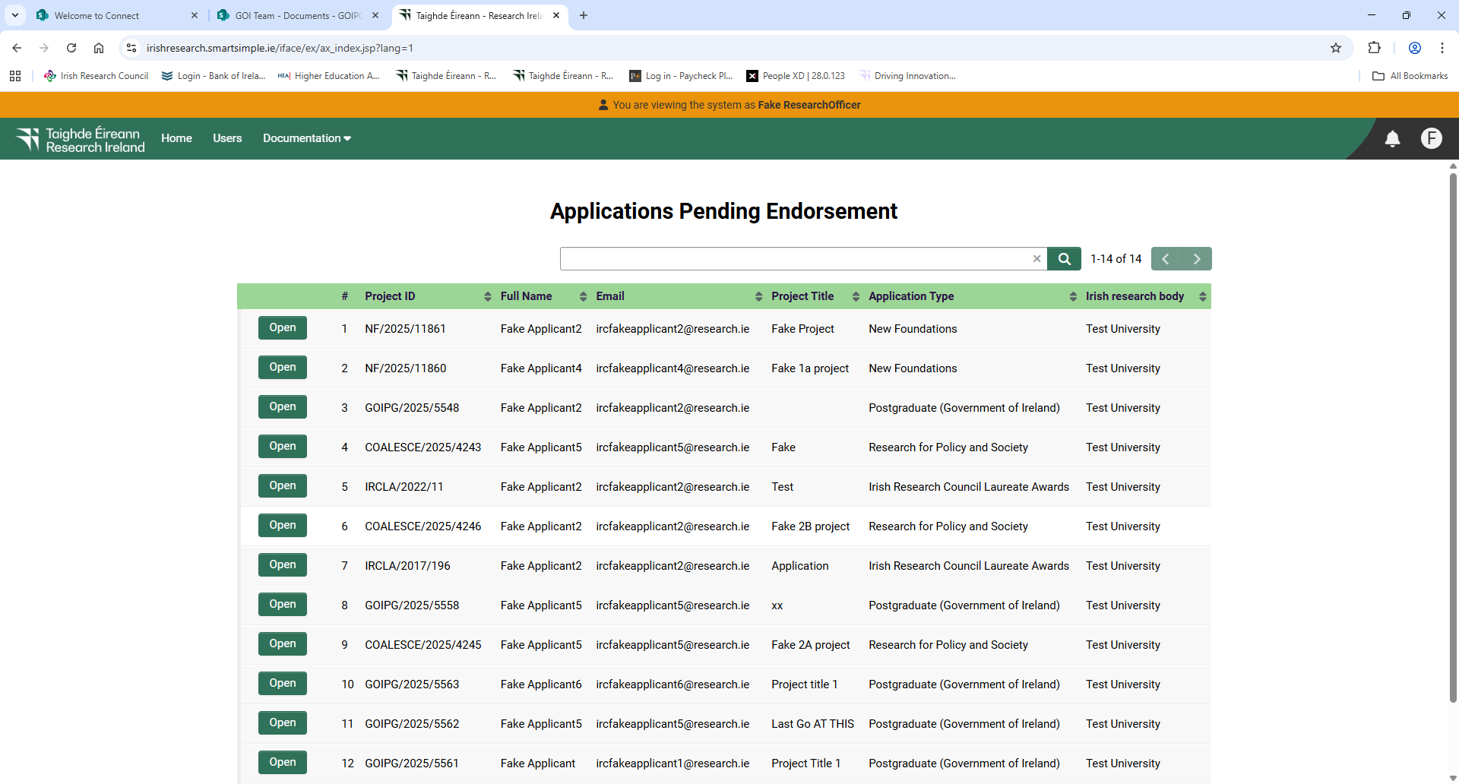

- Please note that you can sort the applications by their programme by clicking on “Application Type” (eg. Postdoctoral Fellowship (Government of Ireland))
- You will then have full visibility of the application by working across the tabs at the top of the page (or clicking on the ‘Print (PDF)’ button):

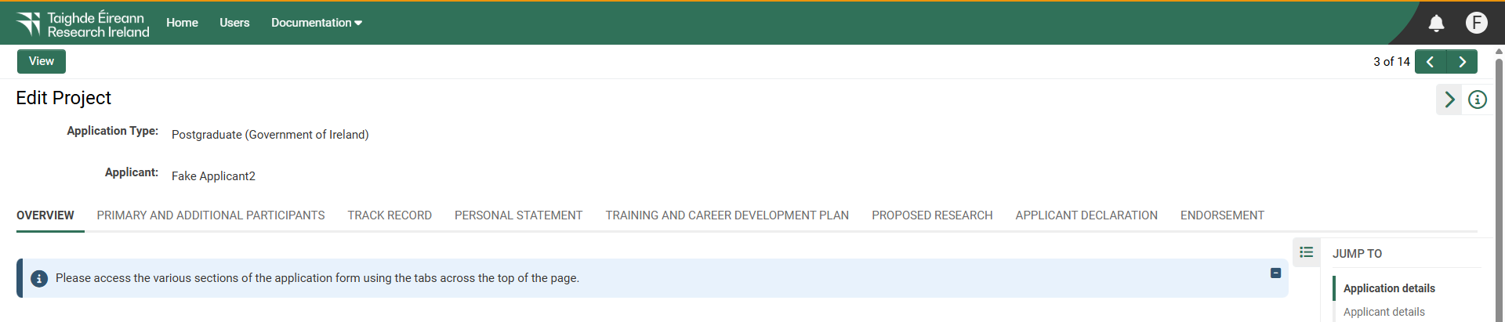

- The Endorsement tab at the far right of the screen contains the area in which to submit the endorsement decision.
- Under the endorsement tab you should select ‘yes’ or ‘no’ to whether your eligible research body wishes to support the candidate’s application to carry out research at your institution and select ‘endorse’ or ‘reject’ under the decision heading.
- Research Officers must agree to the following statement should they decide to endorse the application: I confirm that each application endorsed by the Research Office has been supported by a distinct Mentor (relevant for GOIPD applications), and that no Mentor has supported more than one endorsed GOIPD application

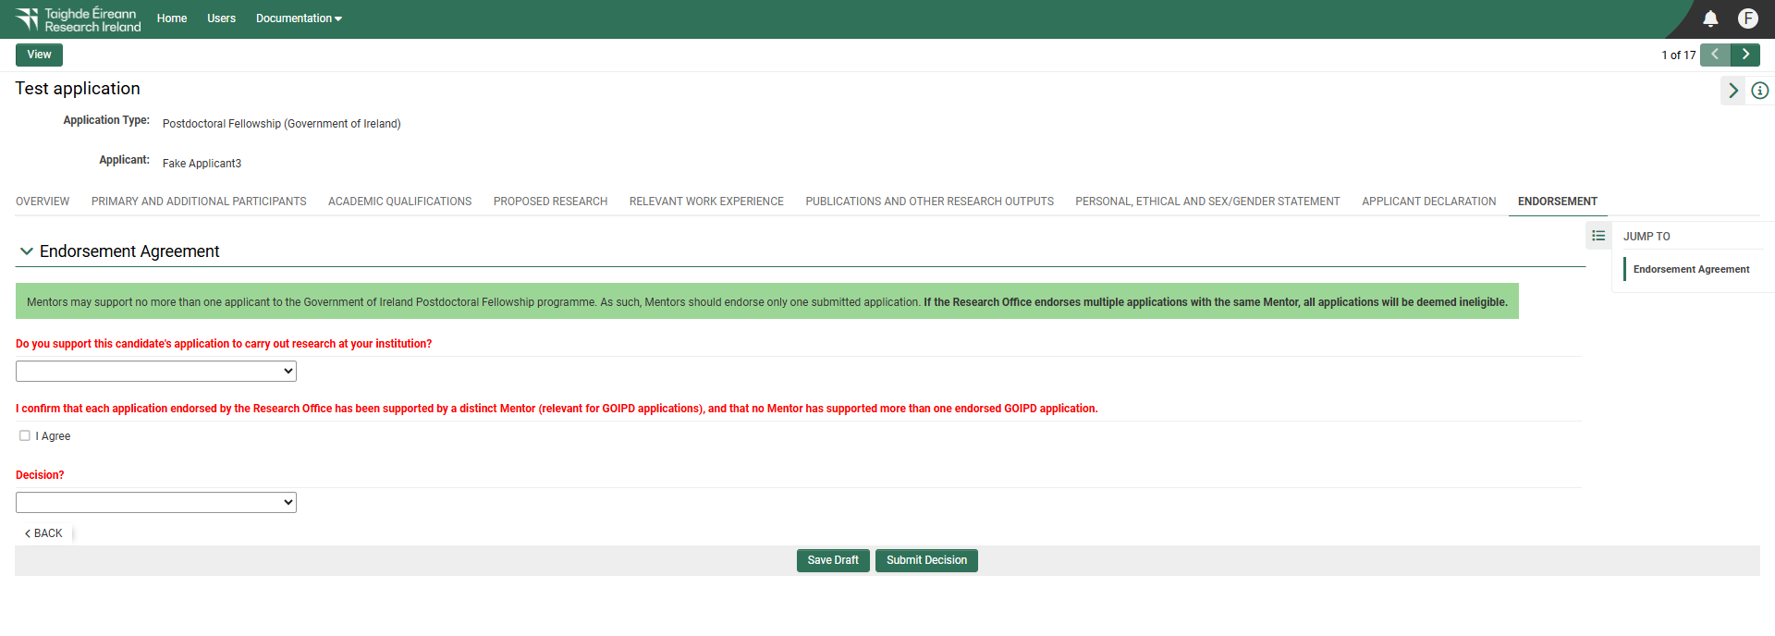

- Should you decide to ‘reject’ an application on behalf of your eligible research body, A ‘Comments’ box will appear and you will be asked to provide a reason for this decision in this box.

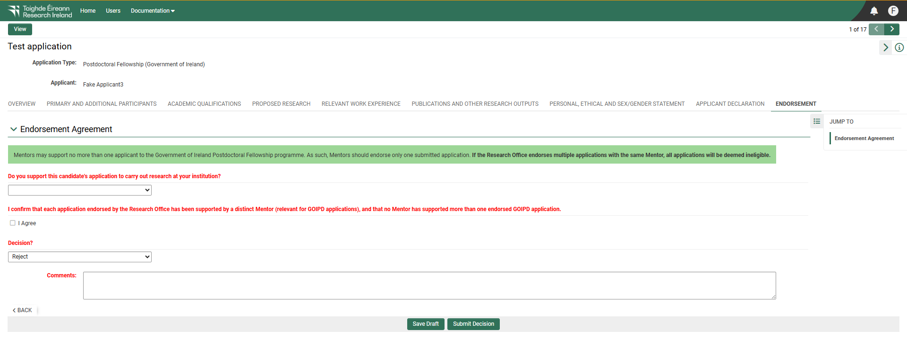

- Click the ‘submit decision’ button at the bottom of the screen once complete.
- At this stage, the endorsement form will be ‘locked’, and no further edits will be possible.
- You will receive an automated email confirming receipt of your decision.
- The applicant will also receive an automated email confirming the decision. If the application is not endorsed, the reason will not be automatically communicated to the applicant.
- You can view all institutional decision statuses by clicking on the ‘submitted applications’ icon on your home screen.

