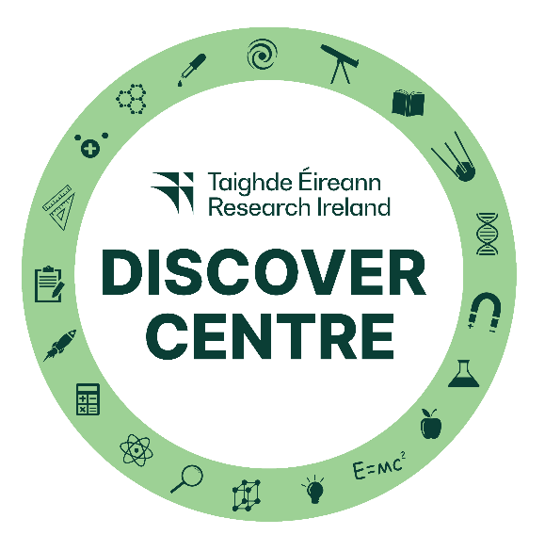
Research Ireland – Discover Centres Network
Data Protection Notice
This Data Protection Notice is issued by Research Ireland, of Three Park Place, Hatch Street Upper, Dublin 2 (“Research Ireland”, or “we”). The purpose of this notice is to inform you of the data relating to you that we may collect and use in connection with the Discover Centres Network and the uses we may make of such data (including disclosures to third parties).
About the Discover Centres Network
The Discover Centres Network (“DCN”) was established in 2005 as part of Research Ireland’s Discover Primary Science and Maths Programme (“DPSM”) which has since rebranded as Curious Minds. Over the past 13 years, the network has grown to over 50 Discover Centres. The DCN offers accredited workshops and outreach programmes for Primary Schools on a wide range of themes encompassing Science, Technology, Engineering, Maths and Space. This supports schools in engaging in science education outside of the classroom in a curriculum relevant and inquiry-based way and provides opportunities to meet scientists and engineers from a range of disciplines.
What data do we collect?
Research Ireland collects the following data in the context of the DCN
(a) name, position, relevant qualifications and experience and contact details of centre’s Discover Centre Network contact person;
(b) [name, position and relevant qualifications and experience of the Discover Centre personnel who are/will be involved in the delivery of workshops and outreach programmes]; and
(c) [name and employing school of teachers who complete evaluation forms].
Who is the data provided by?
The data may be provided to the DCN by the applicant organisation rather than by the individual members of the organisation (although it is usually the case that the centre’s Discover Centre Network contact person is the individual who makes the application on behalf of the applicant organisation). The individual submitting the information on behalf of the organisation shall ensure that all members of the organisation are made fully aware of the content of this Data Protection Notice including, in particular, the uses and disclosures that will be made of their data.
How do we use your information?
The information is used for the following purposes:
(a) to process applications for accrediting a centre as an Research Ireland Discover Centre;
(b) to organise induction training for Discover Centre representatives;
(c) to publish contact details of the Discover Centre Network representative on the Discover Centre website;
(d) to organise quarterly networking meetings for Discover Centre representatives;
(e) to evaluate the programmes delivered by Discover Centres;
(f) to communicate with Discover Centres in relation to meetings, upskilling opportunities and Curious Minds programme developments; and
(g) to engage with Discover Centres in relation to contributions to e-newsletters for schools.
Legal Basis for Processing
The forms of processing referred to in this Data Protection Notice are necessary for the performance by Research Ireland of its statutory functions. This provides the legal basis for processing your personal data as referred to in this Data Protection Notice.
Who will your data be shared with?
Research Ireland may share your data with third parties as reasonably necessary in connection with the activities referred to above, including:
(a) consultants who provide assistance on STEM education programmes, including the observation of workshops and the making of recommendations on accreditation;
(b) [our agents or other third party service providers (e.g. IT service providers, etc.);
(c) our auditors or other professional advisers;
(d) competent regulatory authorities and bodies as requested or required by law; and
(e) the Department of Education or any successor departments from time to time.]
Transfers Abroad
Data that Research Ireland collects from you may be transferred to a destination outside the European Economic Area ("EEA"), including to a jurisdiction where the level of protection afforded to personal data is not as high as that in the European Union. This could occur, for example, where data is hosted overseas or where our IT maintenance/service providers are located overseas. If we transfer personal data to such jurisdictions, we will ensure that appropriate measures are in place to comply with our obligations under applicable law governing such transfers. Such measures may include entering into ‘standard contractual clauses’ in the form approved by the European Commission or, in respect of transfers to the USA, ensuring that the transfer is covered by the EU-US Privacy Shield framework. If you would like to receive further details of the measures that we have taken in this regard, please contact us at dataprivacy@researchireland.ie.
How long do we keep your information?
Research Ireland will only keep your data for such period of time as may be reasonably necessary to fulfil the purposes set out in this Data Protection Notice and, if relevant, to deal with any claim or dispute that might arise in connection with the DCN. Research Ireland requires each Discover Centre to report annually and provide confirmation as to whether the Centre wishes to remain part of the DCN as well as provide up-to-date contact details. In the event that a Centre does not wish to continue its association with the DCN, the contact details of the Centre and its personnel are deleted from the Research Ireland system [except in the case of a dispute].
Security of your information
We have adopted appropriate technical and organisational security measures to protect your information from unauthorised access and against unlawful processing, accidental loss, destruction or damage. We will also ensure that our agents or third party service providers who process your data are required to keep your data safe and secure to at least an equivalent standard.
Your rights
You have the right, subject to certain exceptions, to obtain a copy of your personal data and to have any inaccuracies corrected. You also have the right to have your data erased and to restrict or object to processing of your personal data, though these rights may be limited in some situations and are subject to certain exceptions. In order to exercise any of the rights set out above, please write to us at: Research Ireland, Three Park Place, Hatch Street Upper, Dublin 2. In order to protect your privacy, you may also be asked to provide suitable proof of identification.
Contact / Complaints
Questions, comments and requests regarding this data protection notice or the exercise of your rights are welcomed and should be addressed to Research Ireland, Three Park Place, Hatch Street Upper, Dublin 2 or dataprivacy@researchireland.ie. If you are not happy with the way we have used your information or addressed your rights, you have the right to make a complaint to the Irish Data Protection Commission by emailing info@dataprotection.ie.

