

Research Ireland Discover Centre Network
Guidelines for Applicants 2026

Introduction

What is the Discover Centres Network (DCN)?
The Research Ireland Discover Centres Network (DCN) is a group of independent organisations that offer Research Ireland accredited workshops and outreach programmes for Primary schools on a range of themes encompassing Science, Technology, Engineering, Maths and Space. This supports schools in engaging in informal science education outside of the classroom in a curriculum relevant and inquiry-based way and provides opportunities to meet scientists and engineers from a range of disciplines.

TERMS OF REFERENCE

Background
The Research Ireland Discover Centres Network (DCN) was established as part of the Discover Primary Science and Maths (DPSM) programme in 2005. Since then, the network has grown to over 40 Discover Centres and DPSM has rebranded to Curious Minds. Centres include the Zoo, national parks, interpretive centres, observatories, aquariums and a fab lab.
The DCN offers accredited workshops and outreach programmes for primary schools on a range of themes encompassing Science, Technology, Engineering, Maths and Space.
The Research Ireland Curious Minds Awards provide a flexible model that facilitates schools in dictating their own STEM learning journey and supports the delivery of the STEM Education Policy Statement 2017 - 2026. Schools can gain credit towards their Research Ireland Curious Minds Award by visiting a Centre or engaging in outreach programmes.
The STEM Education Policy Statement reflects how STEM is multi-faceted and goes well beyond the main STEM disciplines of Science, Technology, Engineering and Maths. It allows students to learn and apply content, practices and skills of the STEM disciplines to situations they encounter in their everyday lives to develop STEM literate students. Young children naturally engage in early STEM exploration through hands-on multisensory and creative experiences that develop curiosity, creativity, collaboration, communication and critical thinking skills, which are built on through their primary school experience.
This Policy Statement recognises that STEM learning opportunities present themselves in both formal and informal settings within an evolving eco-system.

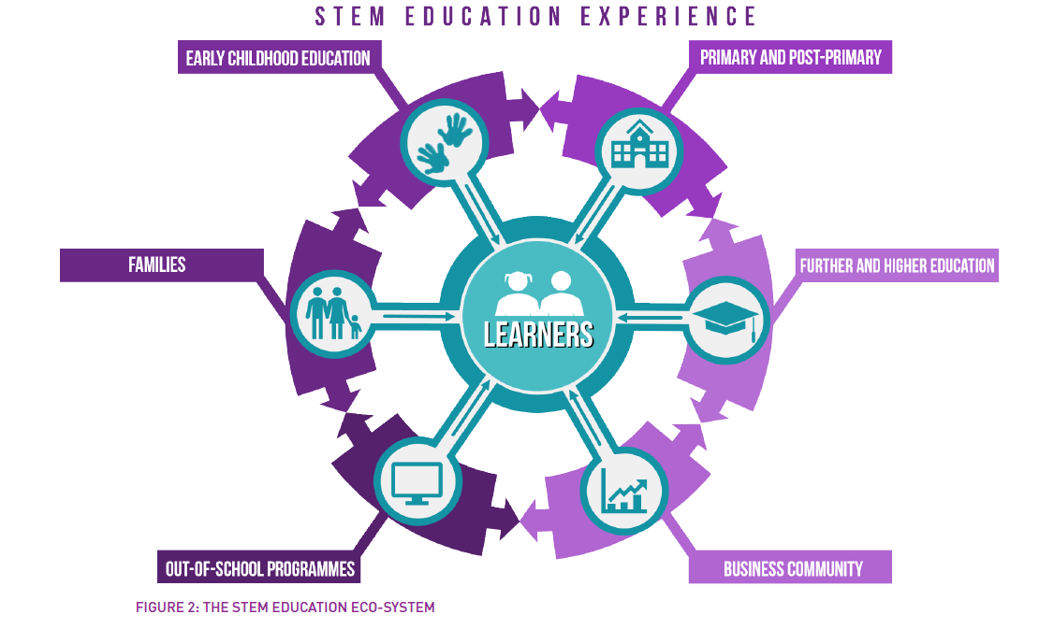
Source: The STEM Education Policy Statement
STEM learning in informal settings is delivered across a multi-stakeholder, multi-programme landscape with contributions from government departments and agencies, business and industry, professional bodies, science centres, community organisations and third level institutions. Bodies, including Research Ireland, support and promote engagement of the Irish public with STEM learning across informal settings which include competitions, exhibitions, science fairs, after-school clubs and STEM Weeks. The Policy Statement will bring greater cohesion to the diversity of STEM activity already taking place in our schools and communities, by recognising the role each stakeholder has to play in creating and maintaining an eco-system for STEM education.

Purpose
The purpose of the network is to:
- Support primary schools to engage in informal STEM education outside of the classroom in a curriculum relevant and inquiry-based way.
- Provide opportunities for children to meet STEM professionals and experience STEM in action in everyday life.
- Support primary schools in attaining the Research Ireland Curious Minds Awards.
- To provide a platform for knowledge sharing and cooperation amongst leading informal STEM experience providers across Ireland.
There are a range of benefits for accredited Centres from sharing ideas and best practice at quarterly network meetings hosted at Research Ireland Discover Centres to CPD opportunities and promotion through the programme website and the Research Ireland Curious Minds quarterly e-newsletter.

Guidelines for applicants
These guidelines are designed to assist you in preparing your application for membership of the DCN. By completing an application, you are confirming that if your application is successful your centre will:

- Be ready to offer a Research Ireland approved programme to primary schools (which you have trialled) by 1 September 2026.
- Have the capacity to accommodate at least one primary school class for a workshop.
- Send a representative of the centre to the Discover Centre Network meeting in July 2026.
- Send a representative of the centre to a Research Ireland Discover Centre induction day if required.
- Apply Research Ireland Curious Minds branding on all documentation relating to your accredited workshop.
- Display Research Ireland Curious Minds branding in the centre as required (typically an accreditation certificate).
- Provide each school with a certificate of attendance at a Research Ireland Curious Minds workshop.
- Link your website to the Research Ireland Curious Minds website.
- Ensure that an evaluation is conducted with each school that participates in the workshop.
- Complete an annual report and sign up to the Centres agreement each year.
- Retain a file of evaluations and submit a summary and samples if required in a report to Research Ireland Curious Minds in July of each year.
- Members of the Research Ireland Discover Centres Network agree that they shall comply with all applicable child welfare law. To the extent any party provides a relevant service within the meaning of section 2 of the Children First Act 2015 (the “CFA”), that party shall comply with the requirements of the CFA. See http://www.tusla.ie/children-first for further information.

PLEASE NOTE: Research Ireland accredits the specific workshops available for primary schools at Discover Centres as being suitable for the Research Ireland Curious Minds programme. Research Ireland has no responsibility whatsoever for the centres other than the accreditation of the specific workshops. It is the responsibility of each school to satisfy itself that child protection, health and safety and other arrangements, including appropriate insurance covers, at a centre meet the school's policies.

All applications must be made online at
https://forms.office.com/e/Lcb37xBv9F
The deadline for applications is 5pm on 20 March 2026

2. Details required for applications

When making an application you will be asked to provide information by selecting answers from a range of options or submitting written answers. Aspects which require you to write a longer, descriptive answer are highlighted in grey in this document to assist you in preparing responses in advance of submitting an online application.

Centre details
Provide the following details:
- Name of Organisation
- Name of Discover Centre, Address, County
- Centre’s designated Research Ireland Curious Minds contact person
- Position
- Relevant qualifications/experience e.g. in STEM and/or Education
- E-mail address
- Website
- Phone number

Workshop details
In this section, please outline details of the STEM workshop the Centre would offer for primary schools if accredited. You will also need to specify the learning outcomes and describe how the workshop will engage children in an inquiry based/hands-on way.

Provide the following details:
- Title of the workshop
- Duration of the workshop
- The classes that the workshop is suitable for (tick as appropriate)

Workshop description (enter your response as text – Max. 200 words)
Provide a short description (maximum 200 words) of the workshop and the activities children will undertake. This might include; hands on science experiments or activities; looking at exhibits or artefacts; play based learning/games; using technology or maths e.g. measuring, weighing; undertaking fieldwork e.g. pond dipping, bug hunting, bird watching, tree identification, planting seeds.

Learning outcomes (enter your response as text)
You will be asked to outline the specific learning outcomes of the workshop, or what the children will be able to do after the workshop. Learning outcomes should be brief, clear, specific statements of what learners will be able to do at the end of a lesson as a result of the activities, teaching and learning that has taken place. The learning outcomes that you use can be based on three areas of learning: knowledge, skills and attitudes.

Linking to the curriculum
The Primary Science Curriculum is structured into four content strands; Living things, Materials, Energy and forces and Environmental awareness and care, subdivided into strand units. You will be asked to select which content strand unit(s) the workshop is relevant to (tick as appropriate).

You can also specify if your workshop covers other aspects of the primary curriculum such as the maths, geography, art or history (tick as appropriate).

You will be asked to outline if the workshop supports development of the following skills outlined in the Primary Science Curriculum
- Working scientifically: Observing, predicting, questioning, investigating, estimating, measuring and analysing (tick as appropriate)
- Designing and making: Exploring, planning, making, evaluating (tick as appropriate)

Additional Details

In the final section of the application please provide the following additional details
- Where you heard about the Research Ireland Discover Centres network and why you want to join (enter your response as text).
- How you intend to promote the workshop/programme to schools in your catchment area; Direct mailing of a brochure to schools, E-mail, Social media, Schools visits, Centres website, Advertisements in the press, Other (tick as appropriate)
- Details of the number of primary school groups that visit the centre or participate in outreach programmes over the school year (tick as appropriate).
- If the programme is available from September to June inclusive (tick as appropriate).

Description that you will use in promotional material/on your website (enter your response as text).
Provide the description that you will use in promotional material/on your website of your proposed Research Ireland/Curious Minds accredited workshop for schools including full details of: How to book; Group size; Cost; If your centre can cater for special need groups; How to find the centre; Details on coach parking; Facilities available on site for eating lunch; Details of what schools should bring; Suitable clothing; Any safety information relevant to schools.

Description of workshop for Research Ireland Curious Minds website (enter your response as text – Max. 150 words)
Provide a paragraph describing the Centre and the proposed Research Ireland/Curious Minds workshop for schools. This will be published on the Discover Centres Network page of the Research Ireland website should your application be successful.

Useful links
The following document and resources may be useful to you in preparing an application.
- You can view details of current network members and their programmes on ResearchIreland.ie
- You can view and download the primary science curriculum here https://www.curriculumonline.ie/getmedia/346522bd-f9f6-49ce-9676-49b59fdb5505/PSEC03c_Science_Curriculum.pdf
- A range of resources developed by Research Ireland to support teaching science through inquiry are available on the Research Ireland website.

If you have any queries, please contact curiousminds@researchireland.ie

Next Steps
Applicants that are successful in progressing to the next stage of the accreditation process will be asked to arrange for a Research Ireland representative to visit the centre during May-June to observe the proposed workshop in action. The Centre will need to arrange for a class of primary school children to attend on the day to participate in the workshop. Approved centres will have provisional membership for a period of one year, which will only be renewed subject to satisfactory participation in the network and completion of annual evaluation reports.

All applications must be made online at
https://forms.office.com/e/Lcb37xBv9F

The deadline for applications is 5pm on 20 March 2026

