

2026 GOVERNMENT OF IRELAND POSTDOCTORAL
FELLOWSHIP SCHEME

APPLICANT’S GUIDE TO THE ONLINE SYSTEM

Key Dates
Call Open: 12:00 (Irish time) 11 September 2025
FAQ deadline: 16:00 (Irish time) 16 October 2025
Applicant deadline: 16:00 (Irish time) 23 October 2025
Mentor deadline: 16:00 (Irish time) 06 November 2025
Research Office Endorsement deadline: 16:00 (Irish time) 13 November 2025
Call outcome: End of April 2026
Grant start date: 01 September 2026

Please note that the terms ‘Mentor’, ‘Mentor in Ireland’, and ‘Academic Mentor’, used interchangeably on the online system and all call documentation, are synonymous and all three refer to the same role of mentoring a Postdoctoral (GOIPD) applicant.

Due to heavy server traffic on the day of the applicant and Mentor in Ireland deadlines, all participants are strongly advised to submit their forms well in advance of the relevant deadline.
Applications cannot be submitted once the deadline has passed. Mentor in Ireland forms cannot be submitted once the deadline has passed.

USING THE ONLINE APPLICATION SYSTEM

The grants management system is only compatible with the two most recent versions of Firefox, Chrome, Internet Explorer and Safari.

- If you have a technical issue regarding use of the online system, please read these guidelines and the FAQ document available on our website. If your issue is not addressed through either of these mechanisms, only then should you email system@researchireland.ie with an outline of your technical issue.
- For any technical query, please include:
  - your application ID
  - the browser you are using
  - and, if appropriate, a screenshot of any error messages.
- Applicants should not log into their profile or application form in different browsers at the same time. This may cause the system to invalidate your login session and any information you have entered will be lost.
- If you enter information and do not click the ‘save draft’ button before navigating away from the page, the information will be lost.
- No alterations can be made to an application once it has been submitted. It is therefore important that you check and re-check the application form until you are fully satisfied with all sections before submitting.

2. Registering as an applicant for the first time

- In order to register as an applicant on the online system for the first time, click here and complete the applicant registration form as prompted.
- Once you have filled in the required details, click ‘submit’ at the bottom of the registration page. A confirmation email will automatically be sent to the email address you have provided. This email confirms that you have successfully registered for the online system and will issue you with a username and password.
- If you do not receive this email, please check your spam folder and ensure that the noreply@researchireland.ie email address is on your ‘safe senders’ list. If you are using an institutional or work email account, you may need to check with your IT department to ensure there is no issue with your organisation’s internal firewall.
- Once you have received your username and password, you should access the online system here using the login details provided.
- If you have lost or forgotten your password, navigate to this link and click ‘forgot password?’ A system-generated password will be forwarded to your email address. If you do not receive this email, please check your spam folder. Please note that it may take up to 15 minutes to receive the email containing your new password.

3. COMPLETING THE PRELIMINARY ELIGIBLITY QUIZ AND Creating an application

- When you log into the online system, you will be presented with the ‘home’ screen below where you can create and edit your application prior to the applicant deadline. The ‘home’ screen is titled Applications and includes several icons including the following:

          - Open Calls
          - Draft Applications
          - Submitted Applications
          - Application Outcomes

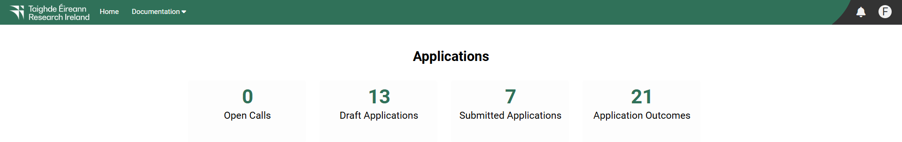

- Begin creating your application by clicking on the ‘Open Calls’ icon.
- When you have clicked on the ‘Open Calls’ icon, a new screen will appear which will provide a table with several headings as follows:
          - #
          - Programme Name
          - Programme Status
          - Call Status
          - Applicant Submission Deadline Date
          - Participants Submission Deadline Date
          - Research Body Submission Deadline Date
          - Apply

The Government of Ireland Postdoctoral Fellowship 2026 Call should appear on this list under the Programme Name heading.
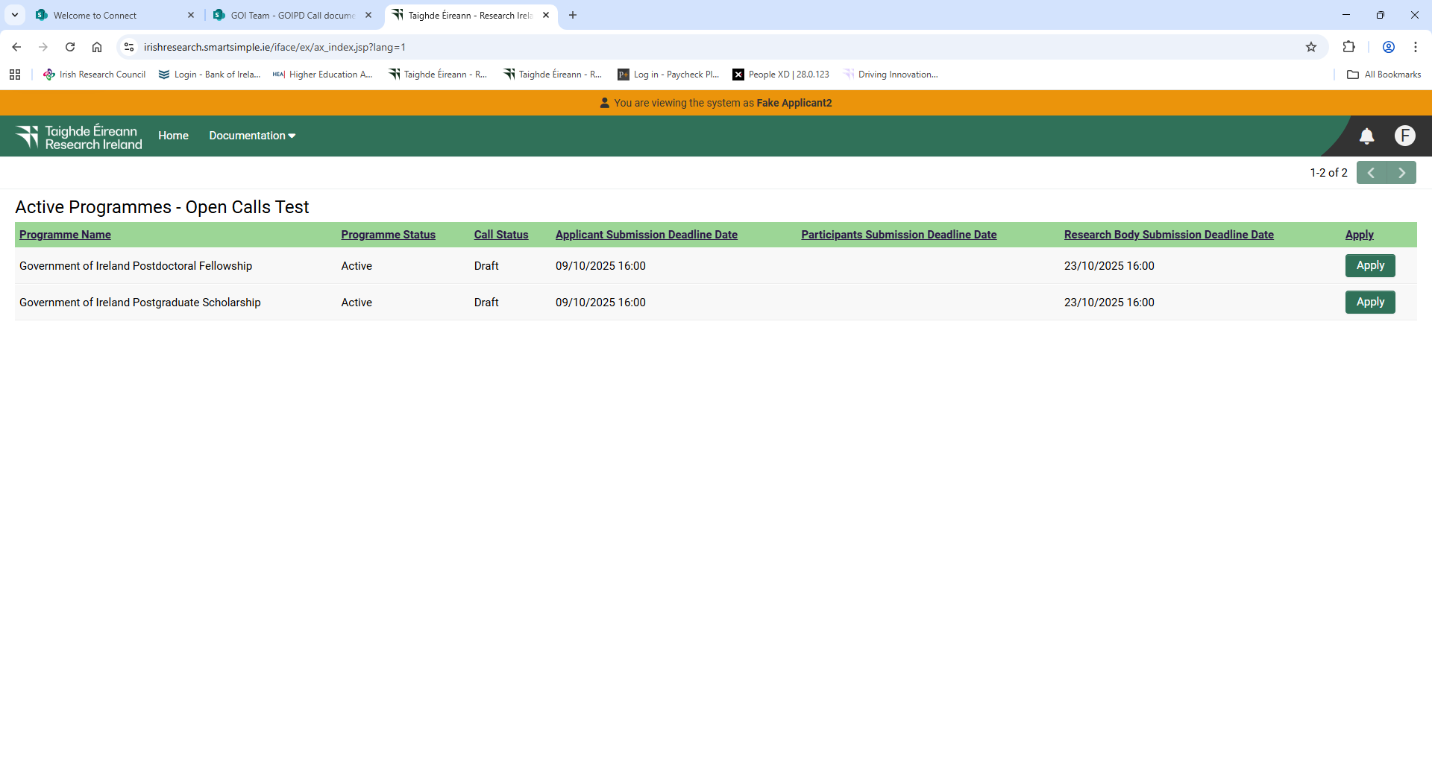

- Under the ‘Apply’ heading, a button titled ‘Apply’ will be available to click.

- Once this button has been clicked, a new screen will appear titled Government of Ireland Postdoctoral Fellowship 2026 with a button titled Begin Preliminary Eligibility Quiz underneath that can be clicked.

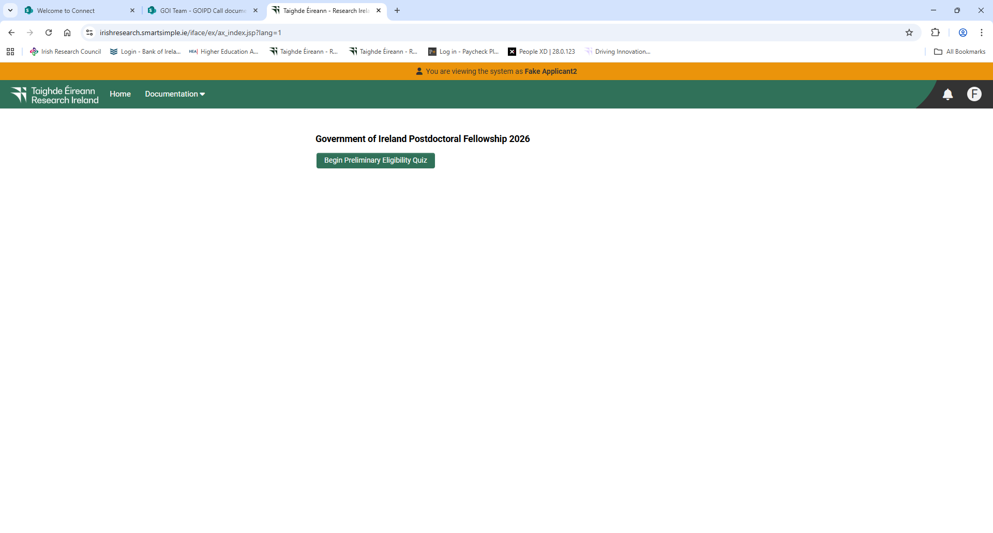

- Click on the ‘Begin Preliminary Eligibility Quiz’ button to access a short quiz which will determine whether or not you meet the preliminary eligibility requirements to apply to the programme. Please note that passing of the preliminary eligibility quiz and provision of access to the application form should not be taken as confirmation that all eligibility requirements for the programme have been met. If it becomes apparent to Research Ireland at any stage of the application, assessment or grant offer process that an applicant does not meet the eligibility criteria, an application will be deemed ineligible, and any grant offer shall be withdrawn.
- Applicants should ensure they have contacted a mentor and that the mentor is willing to support the application before submitting the preliminary eligibility quiz or the application. Applications that are not endorsed by the mentor will be deemed ineligible and will not progress. Research Ireland is not responsible for connecting applicants with potential mentors and WILL NOT assist in this process.
- After beginning the quiz, you may click on ‘save draft’ at the bottom of the screen, which will allow you to save your quiz and re-access it at a later time.

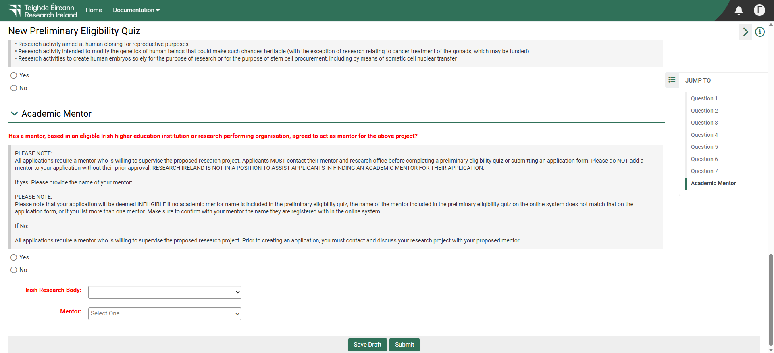

- To do so, after clicking on the ‘open calls’ icon, simply click on ‘Continue Eligibility Quiz’.

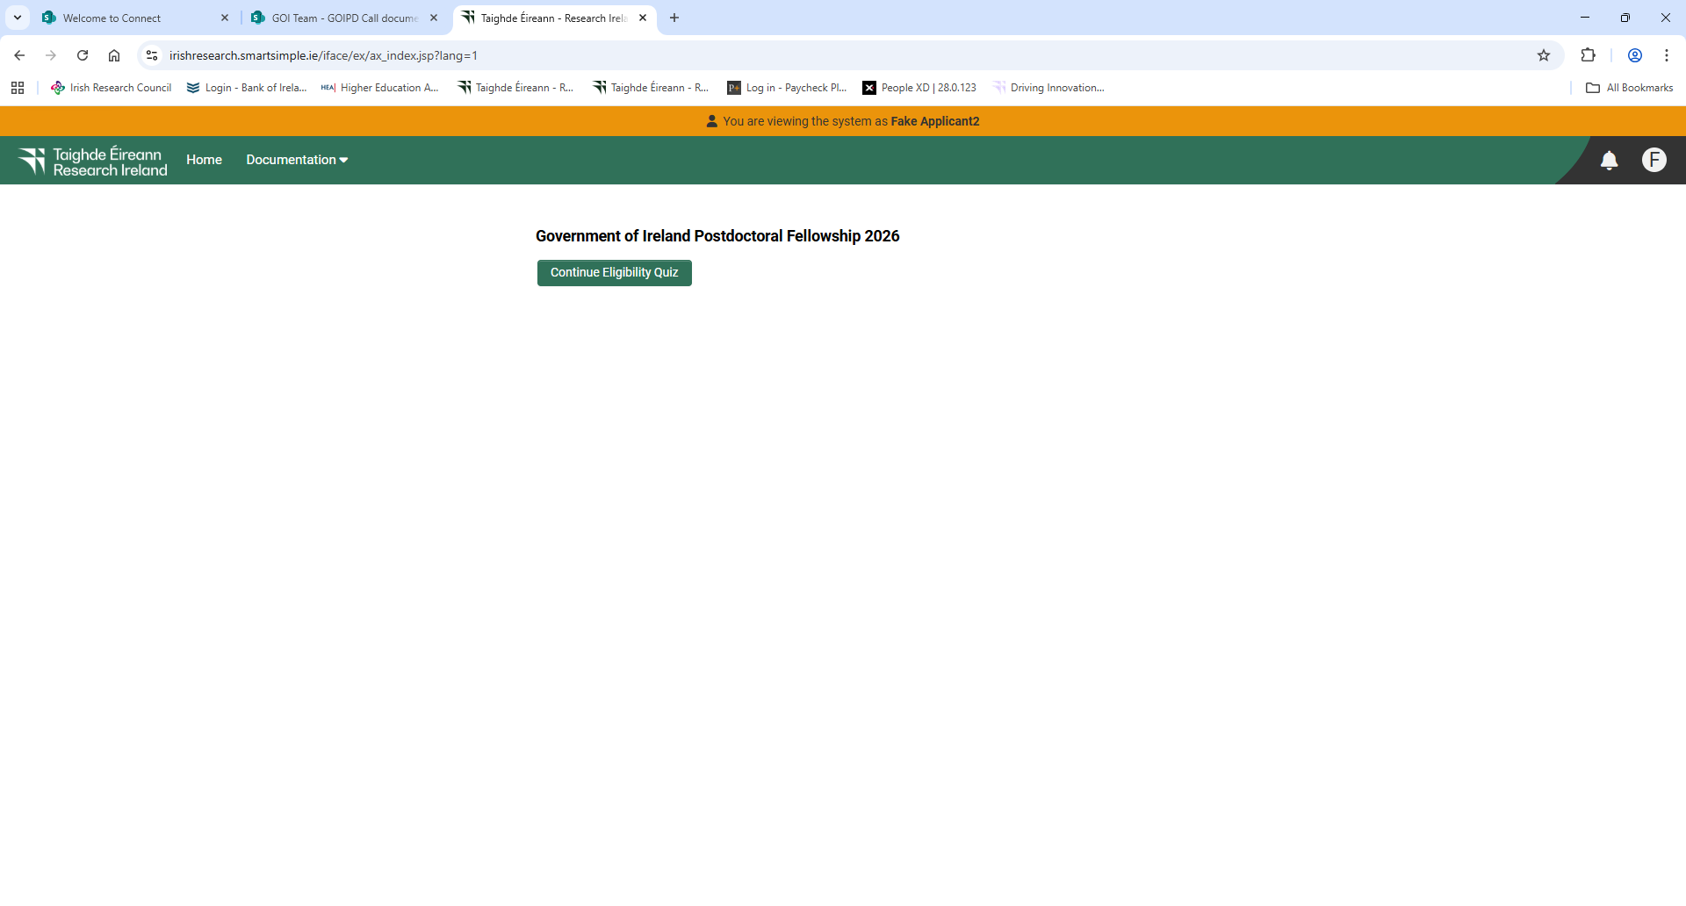
- Applicants must select an Eligible Research Body and Mentor before submitting the quiz. Applicants MUST contact their mentor and research office before completing a preliminary eligibility quiz or submitting an application form. Please do NOT add a mentor to your application without their prior approval. RESEARCH IRELAND IS NOT IN A POSITION TO ASSIST APPLICANTS IN FINDING AN ACADEMIC MENTOR FOR THEIR APPLICATION.
- At the bottom of the preliminary eligibility quiz, your proposed Eligible Research Body should be selected using the ‘Irish research body’ dropdown menu.

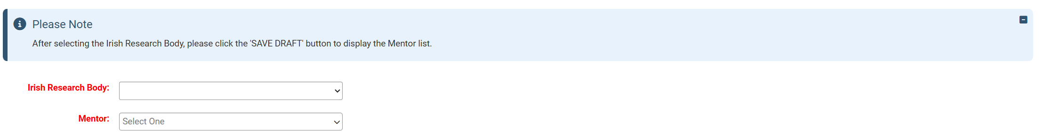

- Please add a Mentor to the preliminary eligibility quiz by first selecting the Irish Research Body. Once the ‘Irish Research Body’ has been selected, the ‘Save Draft’ button MUST be selected before a list of mentors will become available in the ‘Mentor’ field. The Mentor may be added by clicking the dropdown arrow beside the ‘Mentor’ field once the Irish Research body has been selected.

- The Irish Research Body and Mentor details selected here CANNOT be changed once the preliminary eligibility quiz has been submitted. Applicants should ensure they have contacted the mentor and that the mentor is willing to support the application before submitting the preliminary eligibility quiz or the application. Applications that are not endorsed by the academic mentor will be deemed ineligible and will not progress. Research Ireland is not responsible for connecting applicants with potential mentors and WILL NOT assist in this process.
- If you cannot find your chosen Mentor, please contact them to ensure they have been registered through the research office in the eligible research body.
- Mentors may support no more than one applicant to the Government of Ireland Postdoctoral Fellowship programme. As such, Mentors should endorse only one submitted application. If the Research Office endorses multiple applications with the same Mentor, all applications will be deemed ineligible.
- Applicants must agree with the following declaration at the end of the eligibility quiz before being able to submit it: I understand that if the Mentor details entered by me (Applicant) in the preliminary eligibility quiz do not match the Mentor details I (Applicant) subsequently enter on the application form, my application will be deemed ineligible and will not proceed for assessment

- Once you have completed the quiz, click on ‘submit’. No alterations can be made to a preliminary eligibility quiz once it has been submitted. It is therefore important to check and re-check the preliminary eligibility quiz form until you are fully satisfied with all sections before submitting.

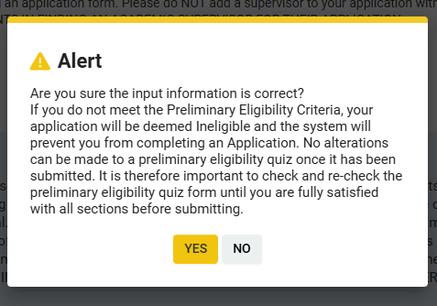

- Potential applicants who do not meet the preliminary eligibility requirements will receive the message ‘You are not eligible for the Government of Ireland Postdoctoral Fellowship, please click Return to Portal button below’ and will not be able to access an application form:

- Potential applicants who meet the preliminary eligibility requirements to apply to the programme will receive the message ‘You passed the Eligibility Quiz for the Government of Ireland Postdoctoral Fellowship. Click the Continue to Application button below to proceed and DO NOT close the window before Saving Draft’ and should click the ‘Continue to Application’ button at the bottom of the page:

- Once you receive the preliminary eligibility message, you must immediately click on ‘Continue to Application’. DO NOT navigate out of the page or reload the page before clicking on ‘Continue to Application’, or before the application form is open. Doing so will prevent you from starting your draft application and from re-submitting the Preliminary Eligibility Quiz. Research Ireland will not reset an Eligibility Quiz.
- Once the application form is open, it will auto-save after 2 to 3 seconds, after which it will become available under the ‘draft applications’ icon in the homepage:

4. ACCESSING THE DRAFT APPLICATION

- The Draft Applications icon on the home screen should be clicked to access the application.
- Once the Draft Applications icon is clicked, a new home screen will appear with the following headings:
          - Project ID
          - Full name
          - Email
          - Project Title
          - Application Type
          - Irish Research body

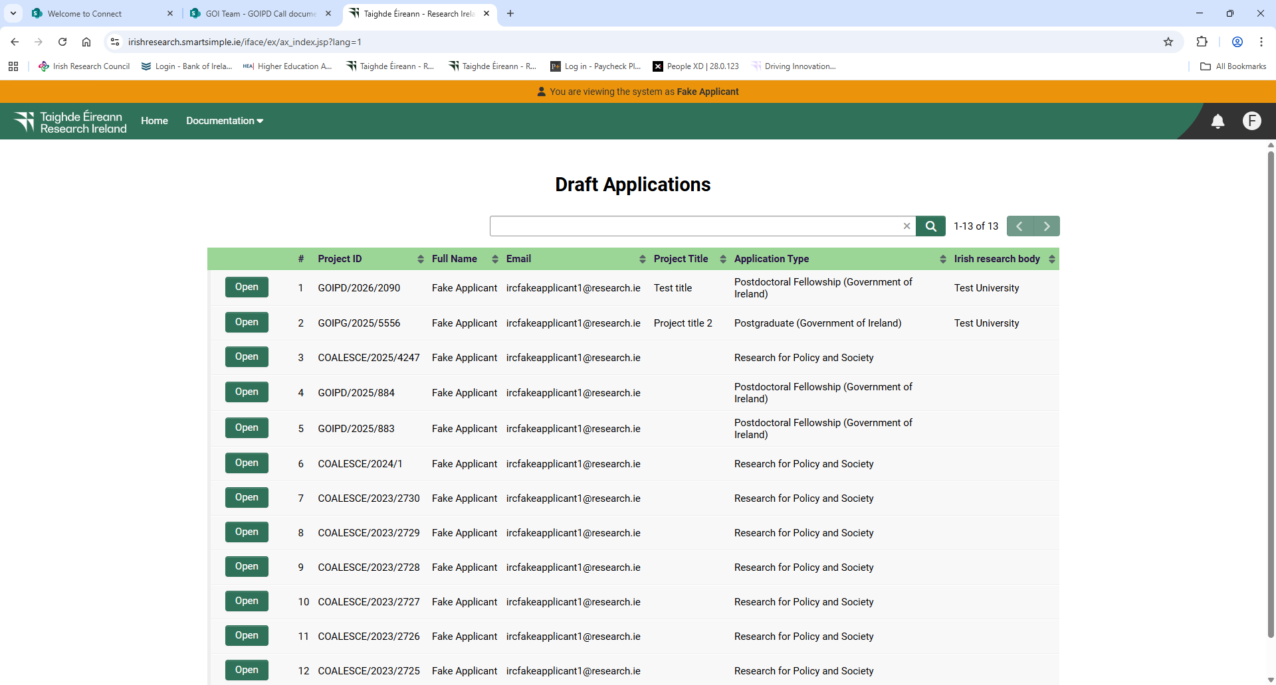

          - A button title ‘Open’ is located to the left of the project ID and should be clicked to access the draft application.
          - Once the draft application has been opened, several tabs will be available for applicants to edit.
          - Overview
          - Primary and Additional Participants
          - Academic Qualifications
          - Proposed Research
          - Relevant Work experience
          - Publications and other research outputs
          - Personal, Ethical and Sex/Gender dimension statements
          - Applicant declaration

          - Applicants may toggle between the tabs to enter information but should ensure to select ‘Save draft’ at the bottom of each window before moving to the next tab to ensure no information is lost.
- Begin by selecting the appropriate fellowship for which you are applying and entering your project title.
- If you have selected ‘yes’ to your application being in Irish, you now have the option to ‘upload’ your own English translation in PDF format.
- The ‘applicant details’ section is largely populated based on your personal profile. If you would like to update any of this information, click ‘save draft’ and navigate back to the home screen where you can find the ‘manage your profile’ icon.
- ORCID provides a persistent digital identifier that distinguishes you from every other researcher and, through integration in key research workflows such as manuscript and grant submission, supports automated linkages between you and your professional activities ensuring that your work is recognised. If you do not currently have an ORCID, please register for one at www.orcid.org.

4. Editing an application

- You can access and edit your application as often as you like prior to the applicant deadline so long as the application has not been submitted and remains in draft status.
- Please ensure that you click the ‘save draft’ button at the bottom of each page before moving from one tab to the next. If you input information on a tab and switch to another without clicking ‘save draft’, this information will be lost. Do not use the browser ‘back’ button at any stage as you may lose essential information. You must be in ‘edit’ mode to input information to your application form. You can switch between the ‘view’ and ‘edit’ modes at the top left of the browser window.

5. Adding A Mentor to an application

- It is the applicant’s responsibility to ensure that their Mentor completes their reference form through the online system by the relevant deadline (see 2026 Call Document). Any application which does not have the required participant form (Mentor in Ireland) completed in full and submitted via the online system by the relevant deadline will be deemed ineligible. The form will not be accepted by email, in hardcopy or by any other means. Research Ireland is not responsible for ensuring that the participant form is submitted on time through the online system. Due to heavy server traffic on the day of the applicant and mentor deadlines, all participants are strongly advised to submit their forms well in advance of the relevant deadline.
- The Mentor in Ireland details must be the same as those input at the ‘Preliminary Eligibility Quiz’ stage. Applications with a discrepancy in the name of the mentor as detailed in the ‘Preliminary Eligibility Quiz’ will be deemed ineligible.
- Please note that the host institution under the Irish Research Body box in the Overview tab of the online application form must be selected prior to attempting to add the Mentor in Ireland.

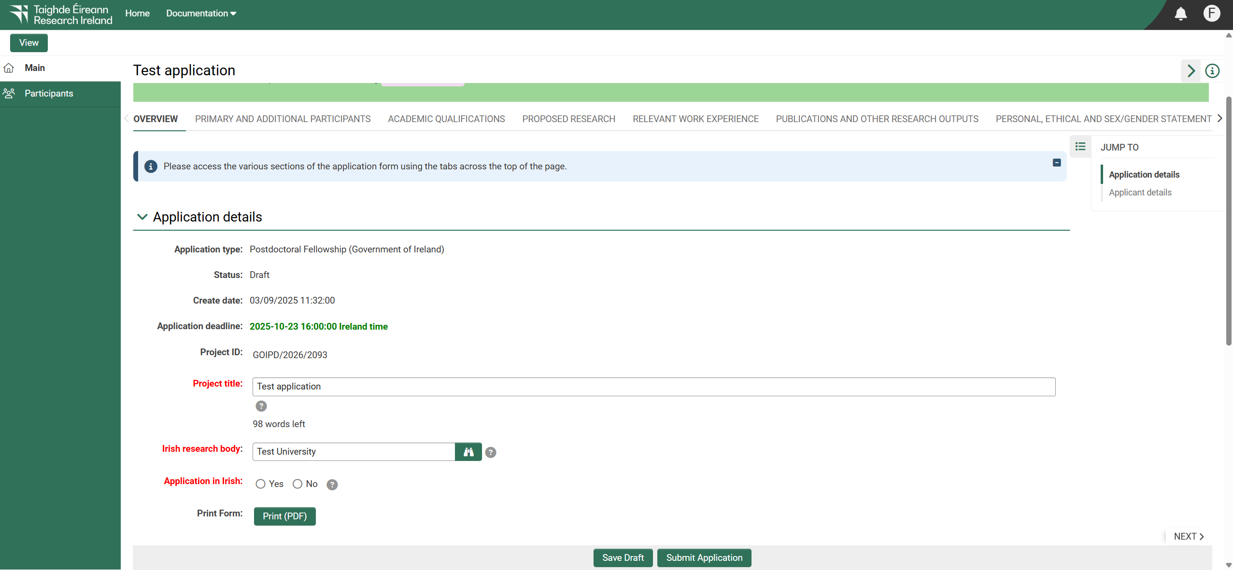

- The Mentor must be added in the “Primary and Additional Participants’ section of the application.

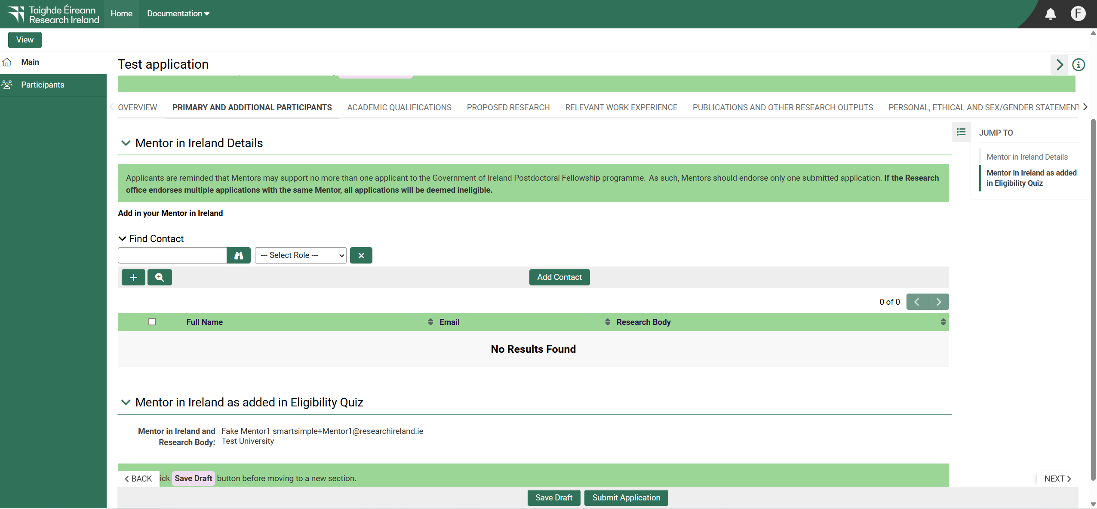

- It is important that you ensure that ‘Mentor in Ireland’ is displayed in the drop-down field to the right of the ‘lookup’ button when adding a mentor to your application. Please do not add any other roles (e.g. supervisor, academic mentor) to your application.

- Use the predictive text field or click the ‘lookup’ button to find and ‘add’ your chosen Mentor in Ireland to your application, by clicking on the ‘Add contact’ button. Click ‘save draft’: your mentor will be associated with your application.
- Your mentor is now an associated participant on your application and will receive an automatically generated email notifying them that they have been added as a participant to your application. This email will contain login details for the online system where they will be able to complete their mentor reference form.
- Applicants are advised to check with their mentors that they have received this email. If they do not receive the email, they should check their spam folder and ensure that the noreply@researchireland.ie email address is on their ‘safe senders’ list. If they are using an institutional or work email account, they may need to check with their IT department to ensure there is no issue with their organisation’s internal firewall.
- If you cannot find your chosen Mentor in Ireland, please contact them to ensure they have been registered through the research office in their Research Body.
- It is not possible to have a secondary mentor in a postdoctoral application although it is possible to acknowledge them in the “Training and Career Development Plan” section for training in relation to specific tasks and career development.
- If you have added the incorrect Mentor in Ireland to your application (i.e. different to the mentor’s name entered in the submitted preliminary eligibility quiz), this must be corrected while the application is in draft status. To remove them from your application, select the check box beside their name at the bottom of the participants tab, click the ‘remove’ button and save your application. The Mentor in Ireland will then be removed, and you can add the correct Mentor in Ireland as per the instructions above. Please be reminded that the mentor associated with your application must be the same as the mentor listed on your submitted preliminary eligibility quiz. If you remove a Mentor in Ireland from your application, they will not be automatically notified. It is the applicant’s responsibility to notify the Mentor in Ireland that they are no longer assigned to an application.
- If the Mentor in Ireland in question has been registered with the incorrect email address, then the research office should contact the Research Ireland to amend the mentor’s contact details on the online system.
- Please note that mentors cannot create or submit their reference form until after you submit your application. Prior to submitting your application, your mentor can view your application in draft status.
- You must agree with the following declaration ‘at the end of the ‘Primary and additional participants’ tab prior to submitting your application:
I understand that if the Mentor details entered by me (Applicant) in the application form do not match the Mentor details I (Applicant) entered on the preliminary eligibility quiz, my application will be deemed ineligible and will not proceed for assessment.

6. Completing the application

- As per the Call Document, in order to ensure a level playing field for all applicants Research Ireland seeks to gender-blind the assessment process for these programmes. As such, applications must be anonymous and free from pronouns or other words which would identify the applicant’s identity and gender. In order to comply with these guidelines, we ask that you do not use your name or give any clue as to your identity and gender - e.g.: use ‘the applicant’ instead of your name if including any of your own publications.
- All degree results as entered in the application form and endorsed by the Eligible Research Body must be the applicant’s overall results and verifiable as such on official transcripts. Regardless of whether they are relevant to the eligibility requirements for the programme, applicants will be required to submit official transcripts for each degree listed in the application confirming the overall result, date of graduation and awarding institution. If such transcripts cannot be presented, or do not verify the information exactly as detailed in the application, any conditional offer of a grant will be withdrawn. If requested, supporting, non-returnable material must be forwarded to Research Ireland for inspection before the award can commence. All transcripts must be appropriately stamped and signed to confirm that they are official documents of the institution.
- If your degree results refer to a grading system other than the Irish honours system (first class honours, upper second class (2.1) honours etc.) or the 4.0 grade point average scale, please enter them exactly as they appear on your transcripts but explain the grading system being referred to in the free text box provided, including the link to any grade converter website used.
- When completing the ‘proposed research’ tab, please consult Research Ireland’s research categorisation document for further descriptions of primary area, discipline and other research areas.
- When completing the ‘personal, ethical and sex/gender statements’ tab, please consult Research Ireland’s sex/gender dimension statement for further information, in the 2026 Call Document.
- Applications are expected to be entirely the applicant’s own work. Random sampling for evidence of plagiarism and excessive duplication will be carried out during the application and grant process. Plagiarism is defined as the appropriation of another person’s ideas, processes, results, or words without giving appropriate credit. It will be deemed that excessive duplication has arisen when significant portions of multiple applications to Research Ireland are similar or identical in content. If such instances of plagiarism or excessive duplication are identified by Research Ireland at any stage during the application or grant process, the relevant application(s) will be deemed ineligible, grant offers will be withdrawn, or active grants will be terminated. Such instances of plagiarism or excessive duplication will also be brought to the attention of the Eligible Research Body and the applicant in question will be prohibited from applying for Research Ireland funding in the future.
- No alterations can be made to an application once it has been submitted. It is therefore important to check and re-check the application form until you are fully satisfied with all sections before submitting. If successful, you will only be offered funding to carry out the project as detailed in the application.
- In order to submit your application, click ‘submit application’ at the bottom of the form.
- A ‘Submission Successful’ message should appear once the application has been submitted successfully. You may return to the home screen by clicking the ‘Return to Portal’ button at the bottom right-hand side of the screen.

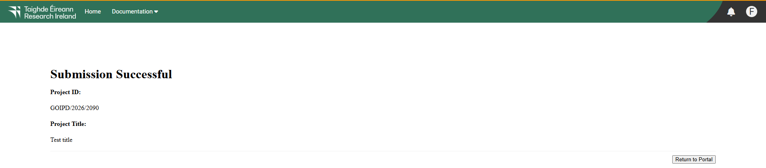

- Please note that the mentor can only complete their form after the application has been submitted.

7. SUBMISSION OF THE MENTOR FORM

- Applicants should ensure they have contacted the mentor and that the mentor is willing to support the application before submitting the preliminary eligibility quiz or the application. Applications that are not endorsed by the academic mentor will be deemed ineligible and will not progress. Research Ireland is not responsible for connecting applicants with potential mentors and WILL NOT assist in this process.
- The mentor details may be added to the application form in the ‘primary and additional participants’ tab (see Section 5 above).
- It is the applicant’s responsibility to ensure that their Mentor completes their reference form through the online system by the relevant deadline (see 2026 Call Document). Any application which does not have the required participant form (Mentor in Ireland) completed in full and submitted via the online system by the relevant deadline will be deemed ineligible. The form will not be accepted by email, in hardcopy or by any other means. Research Ireland is not responsible for ensuring that the participant form is submitted on time through the online system. Due to heavy server traffic on the day of the applicant and mentor deadlines, all participants are strongly advised to submit their forms well in advance of the relevant deadline.
- It is not possible to have a secondary mentor in a postdoctoral application although it is possible to acknowledge them in the “Training and Career Development Plan” section for training in relation to specific tasks and career development.
- Please note that mentors cannot create or submit their reference form until after you submit your application. Prior to submitting your application, your mentor can view your application in draft status.

8. Checking the status of MENTOR form

- Please note that the mentor can only submit their form once the application is submitted. It is the responsibility of the applicant to ensure that the mentor form is submitted by the relevant deadline (see 2026 Call Document).
- The status of these forms can be checked at any stage by logging into the online system and clicking on the ‘submitted applications’ icon on the ‘home’ screen.
- Once the ‘Submitted Activities’ icon has been selected, a new screen will appear that contains the following headings:
      - #
      - Project I
      - Project Title
      - Application Type
      - Irish research body
      - View Application PDF
      - Activities Status

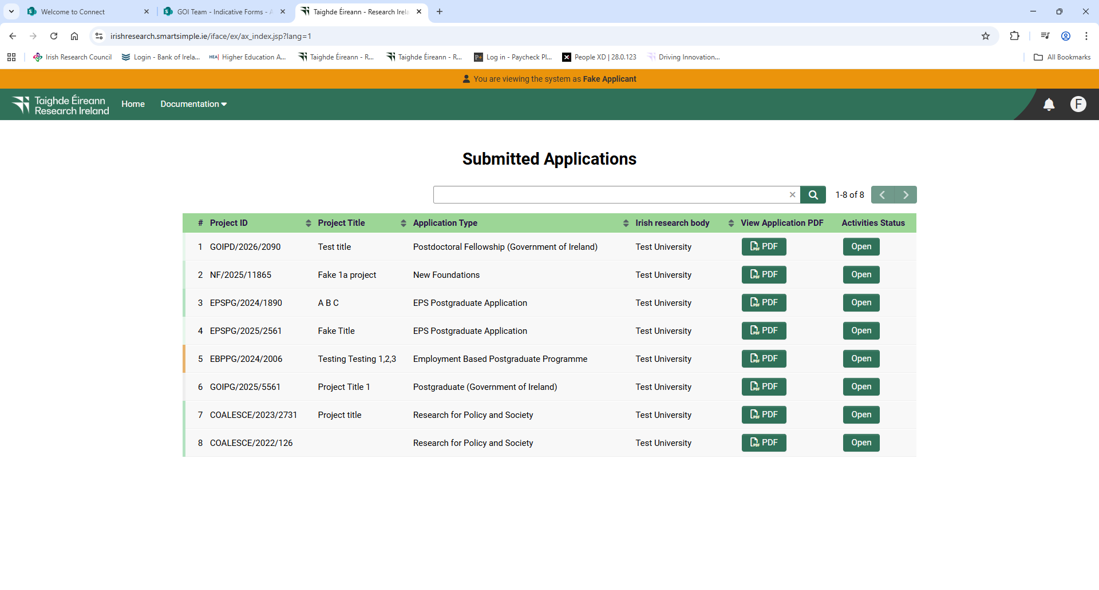

- Click the ‘Open’ button under the ‘Activities Status’ heading to check the status of the mentor form.
- Once the ‘Open’ button has been clicked a message containing the status of the mentor form will be displayed e.g. under the heading ‘Supervisor/Mentor form Status’ the message ‘Mentor Assigned’ should appear followed by ‘Mentor Form in Preparation or in draft’ or ‘Mentor Form submitted or completed’.

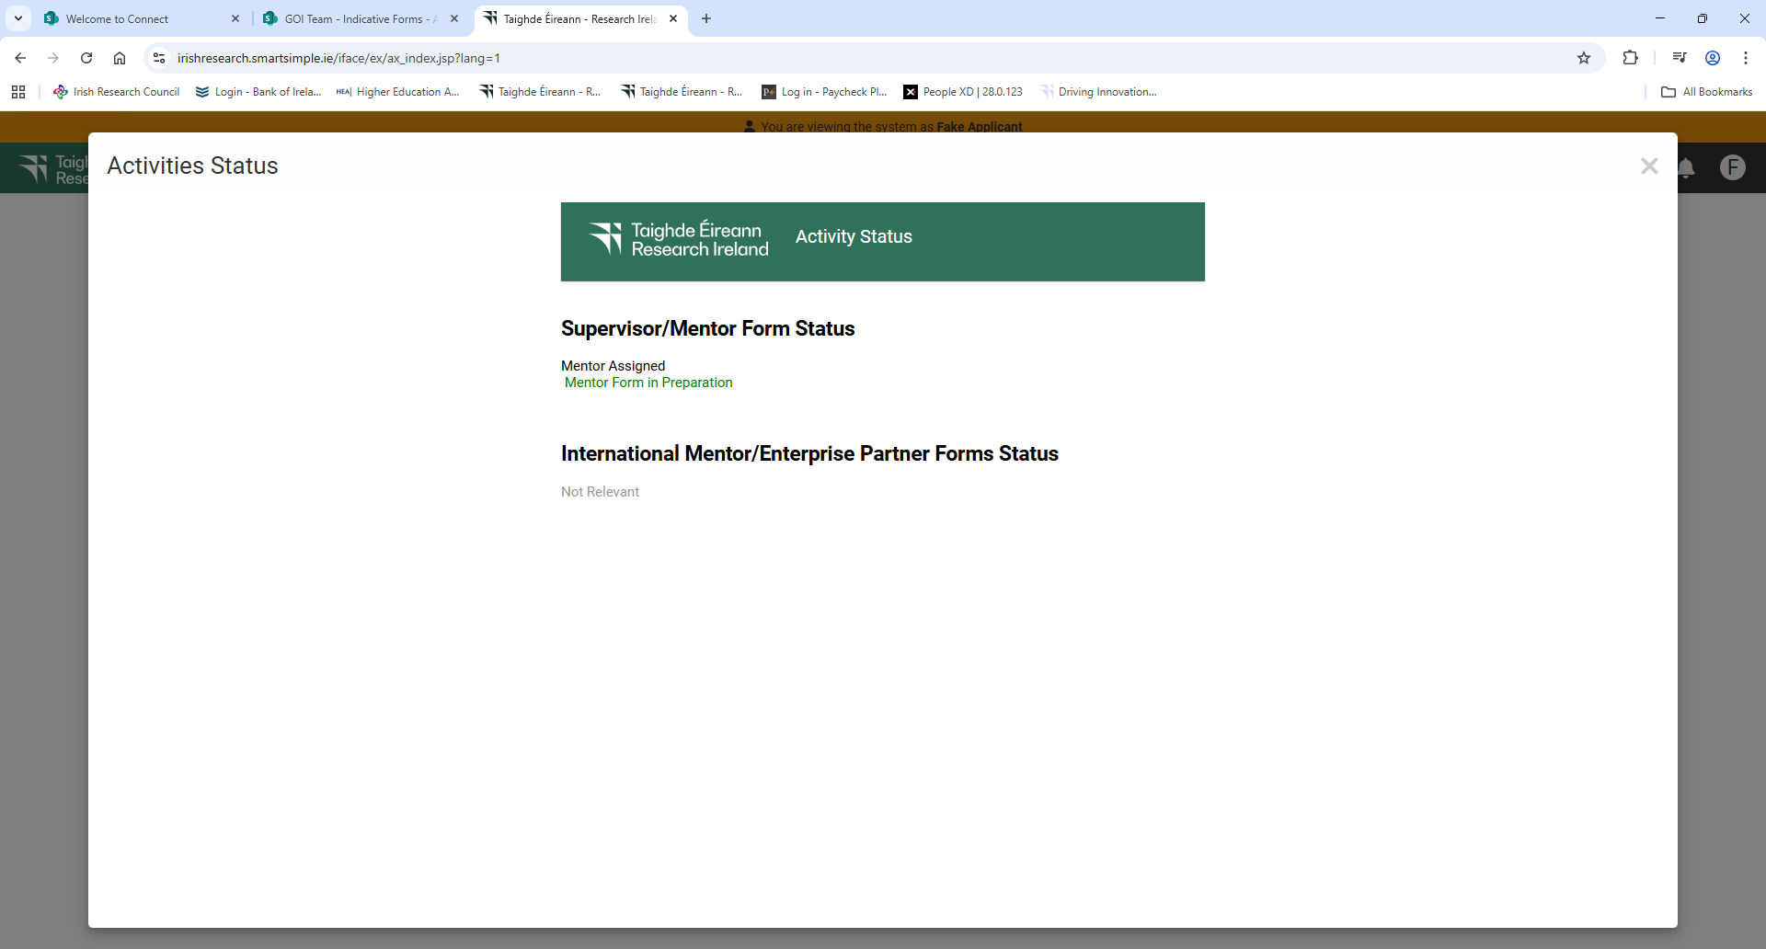

- If the form is listed as ‘in preparation’ or ‘in draft’, it has not been received by Research Ireland. If the form is listed as ‘submitted’ or ‘completed’, it has been received by Research Ireland.
- If necessary, you should contact your proposed mentor to ensure their forms will be submitted before the deadline. The online application system will automatically prevent submission of these forms after the deadline has passed.

9. Endorsement of applications

- The research office endorsement is the final step in the application process. All applications must be endorsed on behalf of the proposed eligible research body by the office of the vice-president/dean of research as applicable.
- Applicants are reminded that Mentors may act as Mentor for no more than one applicant to the Government of Ireland Postdoctoral Fellowship programme. As such, Mentors should endorse only one submitted application. If the Research Office endorses multiple applications with the same Mentor, all applications will be deemed ineligible. There is no restriction on the number of applications for which a Mentor may serve as secondary Mentor.
- You will be able to see the “Research Office Decision” by accessing the PDF of your application by selecting “Submitted Applications” in your portal.
- Please note that the Research Officer decision will only be available in the PDF once the decision is submitted by the Eligible Research Body.

