Research Ireland Public Service Fellowship Call 2026

Call SESAME Guide
January 2026

Applications not adhering to these requirements, or with incomplete content, will be deemed ineligible and will not be accepted for review, regardless of the date of submission.
It is the responsibility of the Lead Applicant to ensure that eligible proposals are received by Research Ireland on, or before, the deadline indicated. In order to safeguard against ineligibility, applicants are reminded to adhere to the guidelines in the call documentation and to review the application prior to submission in SESAME.

Contents
1 Before Starting Your Application 4
2 Eligibility Questions 6
3 Proposal Summary 6
4 Applicant Details 7
4.1 Applicant Details 7
5 Budget 8
5.1 Completing the SESAME Budget Section 9
5.2 Budget Justification 11
6 Research Proposal Documents 11
6.1 Personal Statement 11
6.2 Letters of Support 11
7 Application Preview 12
8 Applicant Agreement to Terms and Conditions 13
9 Research Body Approval 14
10 Proposal Submission 15

This document (Public Service Fellowship SESAME Guide) provides the applicants with guidelines to complete their application on Research Ireland’s Grant Management System SESAME for the Research Ireland Public Service Fellowship Call 2026. This Guide should be read in conjunction with the Research Ireland Public Service Fellowship 2026 Call Document, and should be referenced for filling up and submitting applications. Applications for the Public Service Fellowship Call will only be accepted through SESAME.
Access to SESAME is granted by staff at the Research Office of your host Research Body. Please follow your internal organisational process to request this access if you as an applicant do not have a SESAME profile already. Once you have been registered by your Research Office, you will receive an email containing your Username, Password, and Access PIN.
You will need your username and password to log in to SESAME. The SESAME system is accessed using the following Internet address: https://grants.researchireland.ie/.
SESAME is accessed using the internet; no additional software needs to be installed. You can access SESAME online from any location. The configuration of some browsers and internet infrastructure (popup blockers, firewalls, etc.) can restrict an individual’s access to the internet and as a result to the SESAME system. If you are having any such difficulties, please contact your organisation’s internal IT support team.

The SESAME system is accessed using the following Internet address:
https://grants.researchireland.ie/
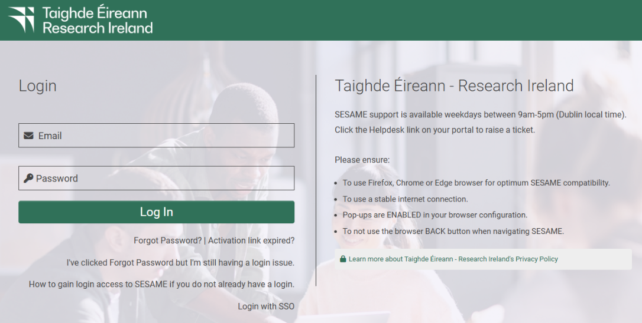

Before Starting Your Application
Before starting the application process on SESAME:
- Refer to the Research Ireland Public Service Fellowship 2026 Call Document to ensure that your team is eligible to apply.
- Please ensure that you as an Applicant has an ORCID ID. If you do not already have one, please go to the ORCID website and create one.
- Log into SESAME and update/create your Researcher Profile. Please note that SESAME is integrated with ORCID making it possible for you to import your publication data directly from ORCID into your Researcher Profile. For the Research Ireland Public Service Fellowship Call, the Applicant is required to complete their Researcher Profile and link it to an ORCID ID before an application can be submitted.
Once you have completed these steps, navigate to your SESAME Workbench, locate the Research Ireland Public Service Fellowship Call and click “View and Apply” button to start the application process.

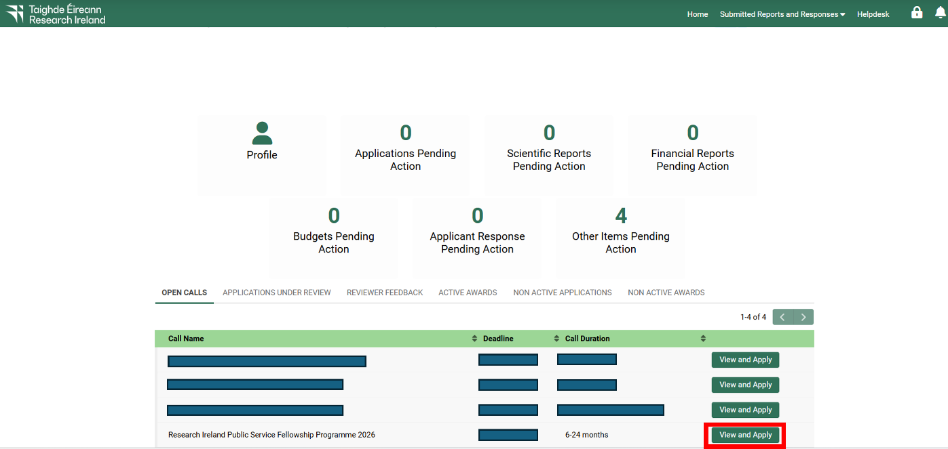

Application Process
The application is completed in a number of steps:
- Completion of field data including text boxes and drop-down boxes.
- Uploading related documents in PDF format.
- Preparing requested budget.
- Submission – once you have completed all the mandatory sections of the application, you submit it to your Research Office for review and endorsement.
You should carefully follow the instructions below to complete the various sections of the application. Please note that some sections of your application must be completed directly in SESAME, and others are completed by uploading PDF documents to SESAME.
- All text in uploaded PDFs should be provided in Aptos font, with minimum font size of 11, and at least single line spacing.
- Uploads in SESAME must be submitted in Adobe or Microsoft PDF format only.
- The number of pages in uploads must not exceed the specifications for any given section.
- Please note you must click “Save Draft” before you can upload documents, prepare budget. Clicking “Save Draft” after uploading documents will make these visible in the application form.
- Uploads for the Research Ireland Public Service Fellowship call include Curriculum Vitae; Personal Statement; Budget Justification document; and Letters of Support.
- Applicants must use the templates provided on the call website.
- Appendices or other unsolicited documentation are not permitted and will be redacted from the application before review.
- File sizes of attachments should be less than 2 GB.
- Applicants must complete all mandatory Researcher Profile fields (marked in red) before submitting an application. It is not possible to submit an application without completing these fields.

Eligibility Questions
Applicants are required to complete the eligibility question upon commencing an application to the Public Service Fellowship call (see Section 2.3 of the Call Document for eligibility details).

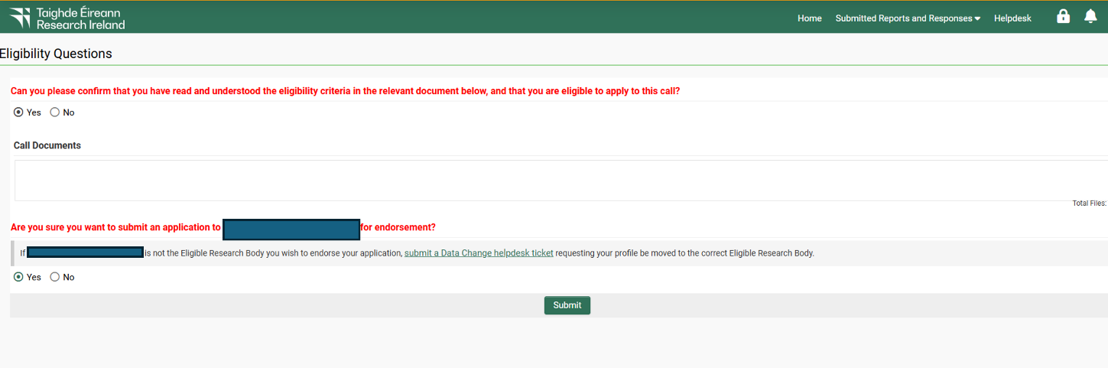

Proposal Summary
Proposal Code and Title (max. 30 words):
Please indicate the project code and title for the secondment which you would like to apply for in the Proposal Title field. The title should match the title of the project included in the selected Project Outline (see “Host Organisation Project Outline Supplement”).
Duration of Award Requested (in months):
Applicants are required to indicate an optimal timeframe (in months) for their secondment which is in line with the working requirements set out in the project, for which they have applied. For full-time Fellowships, the award duration may vary between 6 month and 12 months. For part-time Fellowships, the Award Duration may vary between 12 months and 24 months.
Select whether applying for full-time or part-time:
Applicants are required to indicate their preference for full-time or part-time which is in line with the working requirements set out in the project, for which they have applied. For full-time Fellowships, the award duration may vary between 6 month and 12 months. For part-time Fellowships, the Award Duration may vary between 12 months and 24 months.
Category of Applicant:
Please indicate under which category of applicant you are applying (Faculty Researcher or Postdoctoral Researcher)
Host Organisation:
Please indicate to which Host Organisation you are applying.

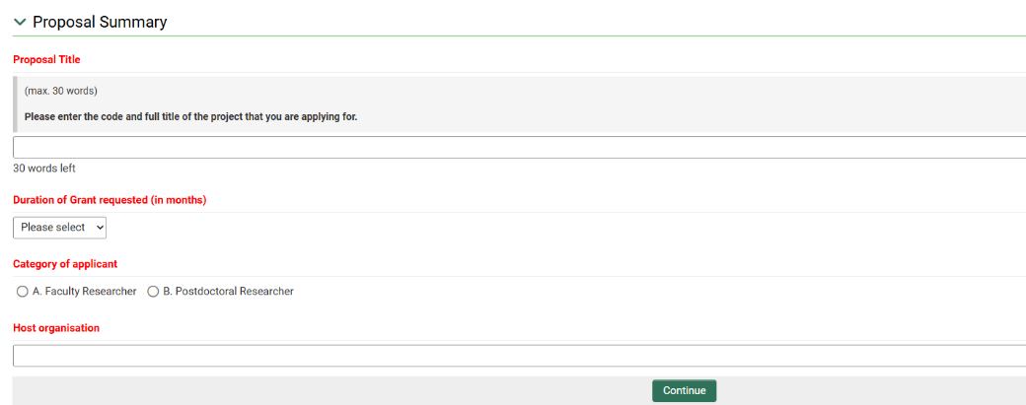

Applicant Details

4.1 Applicant Details
Prior to completing this section of the application form, please ensure that you have completed the mandatory SESAME researcher profile information, including Year of PhD (or equivalent degree).
Time Commitment to Project
Please provide the % time commitment of the Researcher to the project (Placement Time/Award Duration). The time commitment must be 100% for full-time Fellowships. For part-time Fellowships, the Time Commitment is expected to be around 50% of the award duration.
Lead Applicant CV (Upload, max. 3 pages)
A CV of the Lead Applicant (max. 3 pages) using the template provided on the Research Ireland Public Service Fellowship call webpage should be completed and uploaded. Please click on “Save Draft” after upload. The current template allows for the provision of additional information such as that relating to periods of leave from research, where relevant. Also, reference to indicators/metrics such as journal impact factor, h-index and total number of publications are not permitted. If these indicators/metrics are included, they will be redacted prior to expert review. The CV template is also available for download from the Public Service Fellowship webpage.
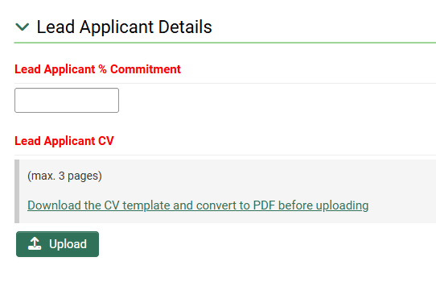

Budget
A Budget Table must be completed as part of your application. The costs eligible for grant support by Research Ireland are those costs which can, uniquely and unambiguously, be identified with the secondment. Applicants must give details of all relevant costs, including travel (mobility allowance) and open access costs. Ensure that the final total provided includes all costs requested from Research Ireland. All grants are made directly to the Applicant’s research body. Please also refer to the Research Grant Terms and Conditions and also the Research Ireland Grant Budget Policy.

Teaching Buyout may be requested for Faculty Researchers when undertaking a secondment. Teaching buyout costs should be calculated on the basis of hiring a temporary lecturer (e.g. at point 1 on the Assistant Lecturer, or equivalent, institutional salary scale) regardless of the seniority of the applicant. Requests must be pro-rata and proportional to the time commitment.
A Salary Contribution for the duration of the secondment may be requested by Postdoctoral Researchers (whether fixed-term or on a contract of indefinite duration). Request must align with appropriate point on the Research Ireland Team Member Salary Scales. Please note:
- The current salary of the applicant must be indicated in the Letter of Support from the Research Body. Based on this information, successful applicants will be awarded a contribution to salary on the subsequent point on the Research Ireland salary scale.
- Salary requests must be pro-rata and proportional to the time commitment.
Mobility Allowance (max. €10,000). A contribution towards travel and accommodation costs directly related to the progress of the Fellowship may be requested to support:
- Travel to and from the Public Service Host Organisation throughout the secondment. This does not include short distance daily commuting but may include relocation costs or long-distance travel within Ireland on a regular basis where required and justified. By default, travel is calculated as the cheapest available public transport option.
- Accommodation costs related to relocation of the Researcher, where relevant and justified.
Open Access Costs - applicants may request open access publishing costs; these costs should be included under the ‘Materials’ cost heading in the SESAME budget table and must be justified in the budget justification. No other materials or consumables costs will be supported by Research Ireland. All other materials costs should be supported by the Host Organisation.

5.1 Completing the SESAME Budget Section
To complete the Budget section, you must fill in the Budget Details table and upload the Budget Justification document (pdf, max 2 pages).
Guidelines for Completion of Budget Details:
- Go to Prepare Budget section and click "Open".
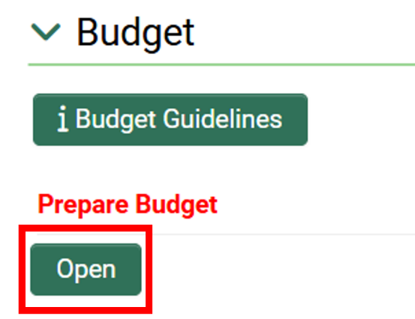

- In the pop-up window click Create a Budget.
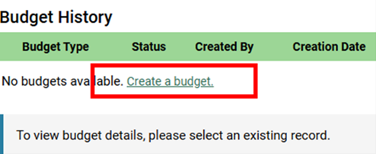

- Select the requested draft budget and click "Open Budget" to edit the budget worksheet.

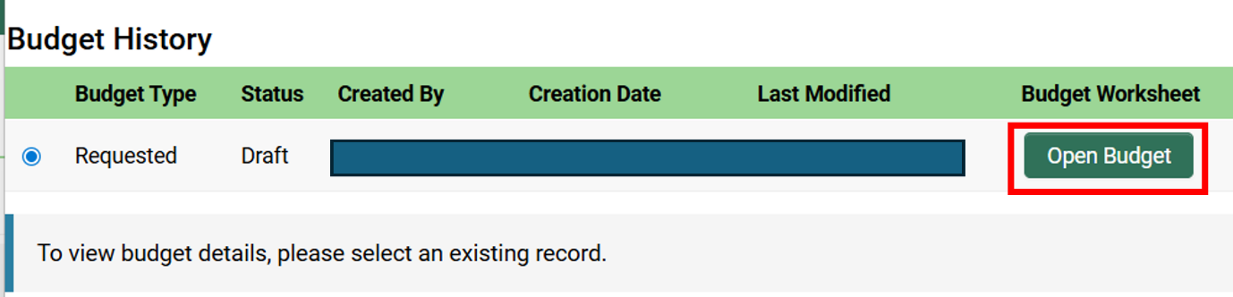

- For each category (Staff and Travel), please enter the total requested budget.
- To add the total, click on the "+" symbol under the budget table.
- To remove line items, click the "‐" symbol to the right of each line item.
- Click "Save" and close the window.

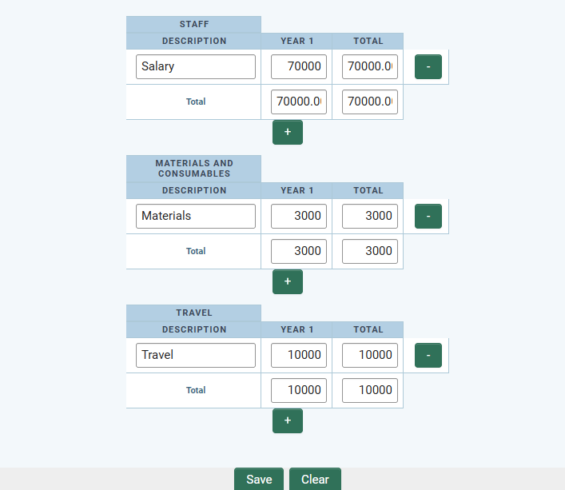
NOTE: Prior to submission, the budget may be edited any number of times.

5.2 Budget Justification
After completing the budget tables, please upload the Budget Justification PDF document (max 1 page).
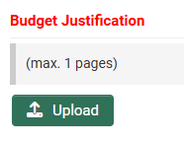

Research Proposal Documents

6.1 Personal Statement
The Applicant should provide a statement to demonstrate their interest in and suitability for the project. This may include details about relevant research experience and expertise as well as other experience to date that would enable them to carry out the project.
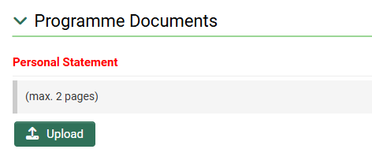

6.2 Letters of Support
The following letters of support must be included (uploads; max. 2 pages for each letter):
Category A Applicants (Faculty Researchers)
- Research Body Letter of Support. The Research Body submitting the application must supply a signed letter of support endorsing the suitability of the Researcher’s expertise to the proposed project.
- Statement from a Research Ireland-funded Applicant (where relevant). If the Applicant is already the holder of an active Research Ireland award, a signed statement must be submitted describing how the Fellowship will not negatively impact on the activities of all active Research Ireland awards in which they are involved, how these awards will be managed for the duration of their Fellowship and what arrangements will be put in place for the supervision of associated team members.

Category B Applicants (Postdoctoral Researchers)
- Research Body Letter of Support. The Research Body submitting the application must supply a signed letter of support which must include details of the Postdoctoral Researcher’s current funding award, details of the funding body and details of the Postdoctoral Researcher’s current remuneration level as aligned to the Research Ireland Team Member Budgeting Scale.
- Research Fellow Salary Justification. If the salary requested is on the Research Fellow or Senior Research Fellow Research Ireland salary scale, an additional formal letter from the Research Body should be supplied describing that the Applicant will be contractually differentiated by the Research Body from the standard cohort of postdoctoral researchers. It is important to note that the inclusion of a support letter will strengthen but not guarantee funding contributions at Research Fellow level. Please refer to the Research Ireland Interim Grant Budget Policy for further details.

NOTE: No additional Letters of Support may be included at the application stage. Any additional/unsolicited Letters of Support will be removed from an application.

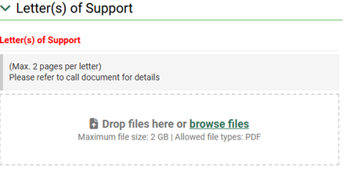

Application Preview
You should view the PDF of your application prior to submission to verify content of your application. Make sure to click “Save Draft” before opening PDF document to ensure all changes are updated. It is the responsibility of the Applicant to ensure that all documentation is included and that the maximum page lengths are not exceeded.
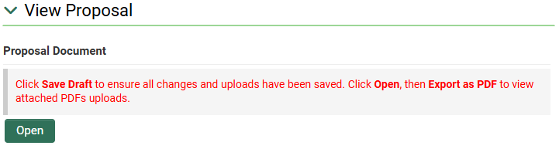
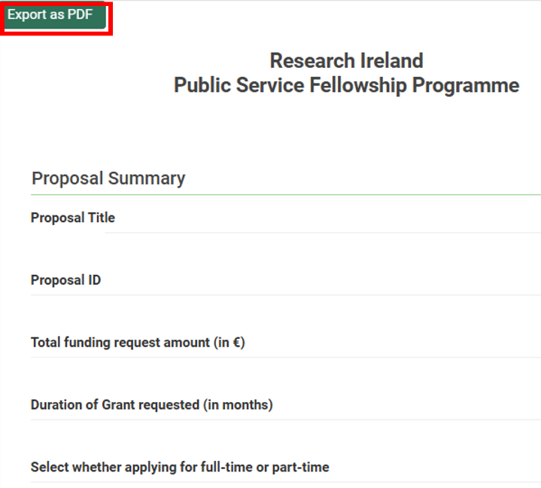

To check that required fields have been completed prior to submission, click "Validate". Validation will also automatically occur when "Submit to RO" is selected. However, it is important to note that there is no system validation on multiple upload file fields, including for example Letters of Support. The number of documents required may vary depending on each application.


Applicant Agreement to Terms and Conditions
Submission of an application confirms acceptance of and agreement with the Research Ireland Terms and Conditions of Research Grants; that the applicant meets eligibility requirements; that the project is in full agreement with all legal and regulatory matters governing research in Ireland; that no aspect of this project is already being funded from another source; and that all details provided are correct.
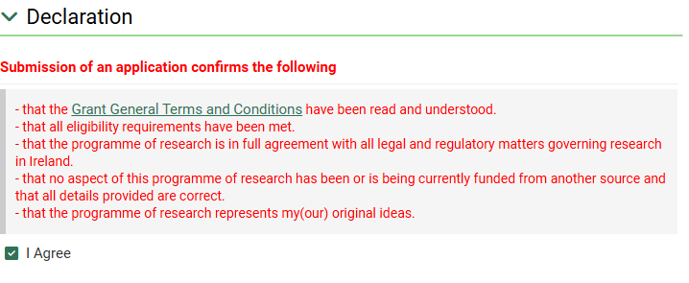
Please note a new field, mandatory for completion for all applications to Research Ireland. You are asked to declare if any generative AI was used in the preparation of the application, and if it was utilised, a description of tools, their versions and an extent to which they were applied must be described. In this case, you are also asked to confirm that application was reviewed for any accuracies, hallucinations, bias, or potential plagiarism.

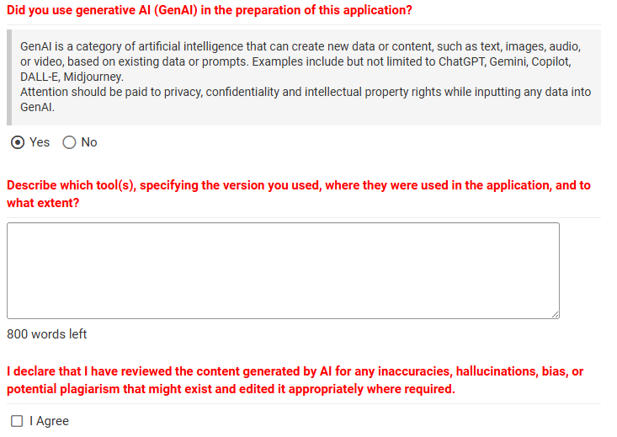

Research Body Approval
For an application to be accepted, it must be authorised for submission by the host research body of the applicant. It should be noted that Research Body submission of an application confirms that the Research Ireland Grant General Terms & Conditions have been read and understood. Submissions may only be made by an authorised representative of the Research Body of the Applicant.
As Applicant, please ensure that sufficient time for the Research Office review and authorisation is provided and follow internal guidance/timelines.

Proposal Submission
Once you have filled in the application fully, previewed the PDF, and agreed with the Research Ireland terms and conditions, click on “Submit to RO”. A submission is made initially to the Research Office of the Applicant for approval, prior to final submission by the Research Office to Research Ireland. The Full Proposal Application Deadline below is for the Research Body to submit endorsed application.
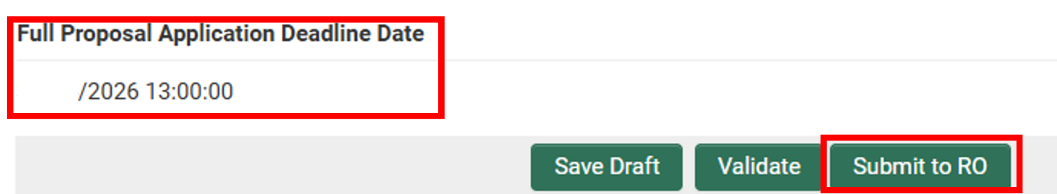

Applications must be received by Research Ireland no later than 13:00 (Dublin Local Time) on 16th April 2026.
Once submitted by the host Research Body to Research Ireland through SESAME, an application cannot be withdrawn and subsequently modified for resubmission in the same call, regardless of the date of submission.
Please contact the Research Office well in advance in order to obtain registration details for SESAME and to become familiar with any internal Research Body submission deadlines.
Please note that after the submission deadline, applications can no longer be submitted in SESAME.
Applicants will receive a notification from SESAME periodically when the status of their proposal changes. Alternatively, the status of a proposal (e.g., where a proposal is pending Research Office approval or is under review at Research Ireland) is displayed in SESAME.

https://www.researchireland.ie/wp-content/uploads/2026/01/Public-Service-Fellowship-Call-Document-2026.pdf
http://orcid.org/
https://www.researchireland.ie/wp-content/uploads/2026/01/Public-Service-Fellowship-Call-Document-2026.pdf
https://www.researchireland.ie/funding/public-service-fellowship/
https://www.researchireland.ie/about/policies/grant-terms-and-conditions/
https://www.researchireland.ie/wp-content/uploads/2025/08/Research-Ireland-Grant-Budget-Policy-Interim.pdf
https://www.researchireland.ie/wp-content/uploads/2025/06/RESEARCH-IRELAND-Team-member-salary-scales_Jan-2024-to-Jun-2026.pdf
https://www.researchireland.ie/wp-content/uploads/2025/08/Research-Ireland-Grant-Budget-Policy-Interim.pdf

