
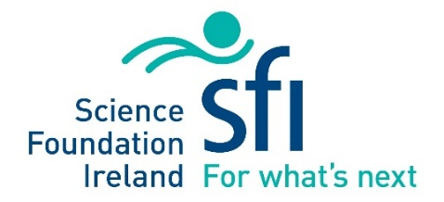
EPSRC-SFI Full Application

PROGRAMME NAME
EPSRC-SFI Joint Research Grants
TITLE OF PROPOSAL (max. 150 characters)
EPSRC-SFI:

FULL NAME OF EPSRC PROJECT LEAD(S) | HOST INSTITUTION(S)
FULL NAME OF SFI CO-LEAD(S) | HOST INSTITUTION(S)
Please note – if any SFI Co-leads have been added to the proposal since the Expression of Interest stage, information on their position/job title and contract status (permanent/temporary) must be provided.
% SFI CO-LEAD (S) COMMITMENT | % EPSRC PROJECT LEAD COMMITMENT
TOTAL REQUESTED SFI BUDGET (€) | TOTAL REQUESTED EPSRC BUDGET (£)
REQUESTED STARTING DATE | PROPOSED DURATION (12 - 60 MONTHS)

Signatures below confirm acceptance and agreement with the SFI grants and awards Terms and Conditions, and that the institution ensures the applicant meets eligibility requirements, and that the project is in full agreement with all legal and regulatory matters governing research in Ireland, and no aspect of this project is already being funded from another source and all details provided are correct.
INSTITUTIONAL SIGNATORY AUTHORITY (ROI LEAD INSTITUTION ONLY)

Name:

Position:

Email:

Signed:

Date:

