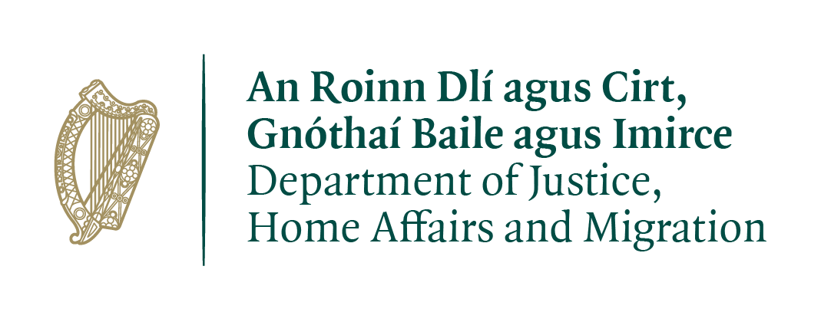

Research Ireland Public Service Fellowship 2026
This project will require Security Clearance

Name of Governmental Department or Agency
Department of Justice, Home Affairs and Migration

Title of the Project
Victims Support Services – Drivers of Engagement

Description of the Project
The Programme for Government commits to a more victim-centred justice system, expanding rights and improving access to support services for victims of crime.
Exploring the experience of victims and utilising learnings from other jurisdictions, and sectors, this study will identify practical ways to increase access and uptake of victim support services in Ireland building on the work that the Department of Justice, Home Affairs and Migration has already done in this area. The research arises in the context of the commitment in the Programme for Government to advance victim-centred justice reforms and to ensure compliance with the EU Victims’ Directive which has been transposed into domestic law via the Victims of Crime Act 2017.
Current uptake of victim’s services remains low in comparison to victimisation rates. The reasons for this are not fully understood and likely span a range of issues including awareness, trust, timing, consent, data flows, eligibility rules, capacity, and cost.
The research will explore a range of approaches to improving victims’ engagement with services, potentially including: behavioural and communication interventions; process tweaks or changes within existing models and alternative referral models including opt-in, prompted-opt-in, and opt-out or hybrid defaults.
Importantly the research will consider the extent to which such approaches may be applicable in the Irish context with consideration given to equity, consent and autonomy, lawfulness, alignment with EU commitments and data protection, provider capacity, cost, acceptability to victims, and operational feasibility.
The findings will assist in guiding the Department’s efforts to make the criminal justice system more victim centred and any related legislative or policy developments.
Key research questions, to be explored:
- What are the main barriers and attrition points along the victim referral and engagement pathway in Ireland?
- The potential impact of behavioural and communication interventions in increasing informed uptake without undermining autonomy?
- What process changes or alternative referral models, if any, deliver material gains in reach and equity within legal constraints?
- What safeguards are needed to ensure ethical, lawful and trauma-informed practice?

Project Scope
A. Irish Baseline Mapping
- Define the scope of victim referral processes to be examined, specifying the pathways, crime types, and service contexts included. Prioritise up to four interfaces for detailed analysis, with disaggregation where possible.
- Document current referral processes for the prioritised interfaces, including legal bases and data flows. Build a simple funnel from contact to sustained engagement using existing administrative data where available.
- Identify and explore experiences of victims, points of attrition and reasons for same.
B. Comparative case studies
- Explore approaches from other jurisdictions and/or sectors. Emphasis on drivers of services uptake - what was tried, legal footing, measured impact, costs, and safeguards.
C. Drivers of service uptake
- Rapid evidence review potentially exploring engagement with vulnerable groups, drivers for service uptake, potential use of behavioural economics informed approaches
- Interviews and structured workshops with service providers, advocates and front-line staff of authorities referring victims of crime, such as An Garda Síochána and organisations providing support services.

D. Legal and data considerations
- Assessment of lawful consent bases, data-sharing mechanisms, and development of sample DPIA templates and data-flow diagram

Skills/Expertise Required
- Experience in comparative policy analysis and evidence synthesis across justice and social policy systems.
- Familiarity with the EU Victims’ Directives and national victim support frameworks.
- Strong stakeholder engagement skills, including ability to work with senior officials, statutory agencies, and service providers.
- Understanding of data protection law, including DPIA and lawful-processing principles.
- Desirable:
  - strong grasp of system design in the context of social services.
  - knowledge and expertise in the use of behavioural economics in communications and service design

Expected Outputs of Project
- Evidence Review and Case Study Report, combining comparative findings and Irish baseline mapping.
- Options Paper/ Policy Note containing concise synthesis highlighting trade-offs, decision criteria, and key legal tests.
- Short presentation/workshop with Department of Justice, Home Affairs and Migration and victim support stakeholders; such as the Victims Forum.

Working Arrangements
The candidate will be expected to attend the office 2 days per week if full-time and 1 day per week if part-time.

Project duration and expected commitment
The Department has a preference for completion on a part time basis within 18 months. However, we are open to 12 – 24 month timeframes.

Project lead
Alice Wainwright, Head of Research and Evaluation

